**Beths Grammar School**

Headteacher: Mr R J Blyghton

**BETHS VIP**

(Can you find the V.I.P. words hiding in this week’s edition?)

**Messages from Mr Blyghton, Headteacher**

I hope that students have enjoyed the last week of term with the Enterprise activities for Years 7-10, the activities for Year 12 on Wednesday afternoon – which saw a very exciting tug of war with both staff and students involved, and the final barbecues for KS3 students on the Friday.

A reminder that, in September, we will return for a staff only day on Wednesday 1 September, with the new Year 7 students joining us on Thursday 2 September and the new Year 12 students joining them on Friday 3 September. All other students will return to school on Monday 6 September. I will, however, be in touch with you at the end of August to confirm all of these arrangements.

Finally, I know this has been another very difficult year for us all and, with the cases of Covid-19 rising rapidly, I hope that you and your families remain safe over the summer break and enjoy the chance to get some well-deserved sunshine. I’m hoping to be spending my vacation in Poole, weather permitting!

***Mr R J Blyghton***

**What’s been happening in class?**

**Art Exhibition**

A big well done to all our Beths students for their exceptional hard work and effort in challenging circumstances. The Art Department wishes to thank; Gallery 32 for the kind use of their space, Beths Parents Association for their ongoing contributions towards equipment and both parents and Beths staff for all their support throughout the year.

A big thank you from Beths Art Department.

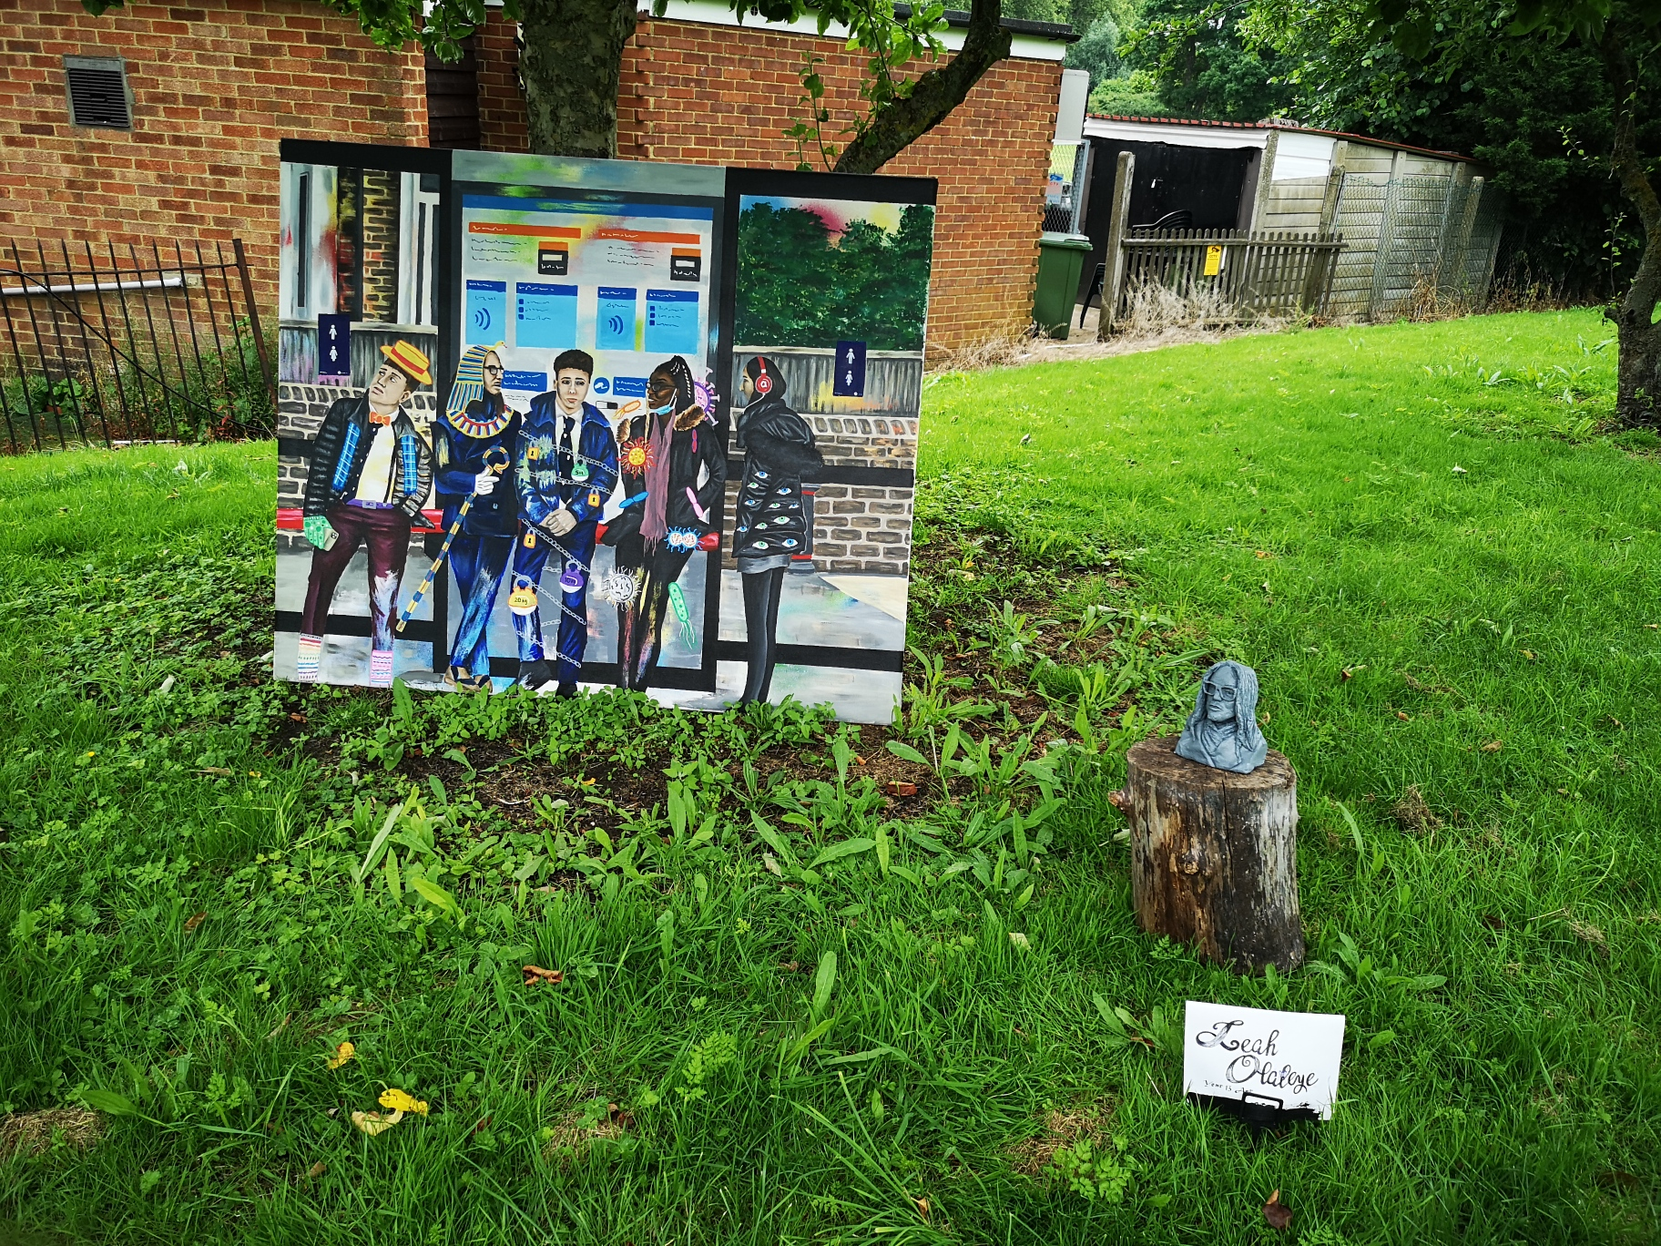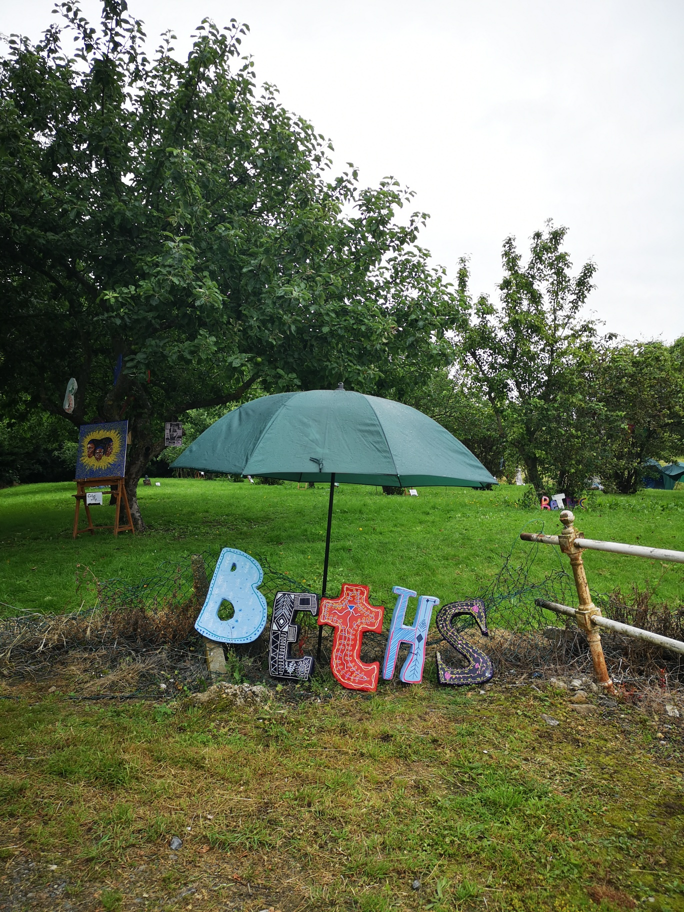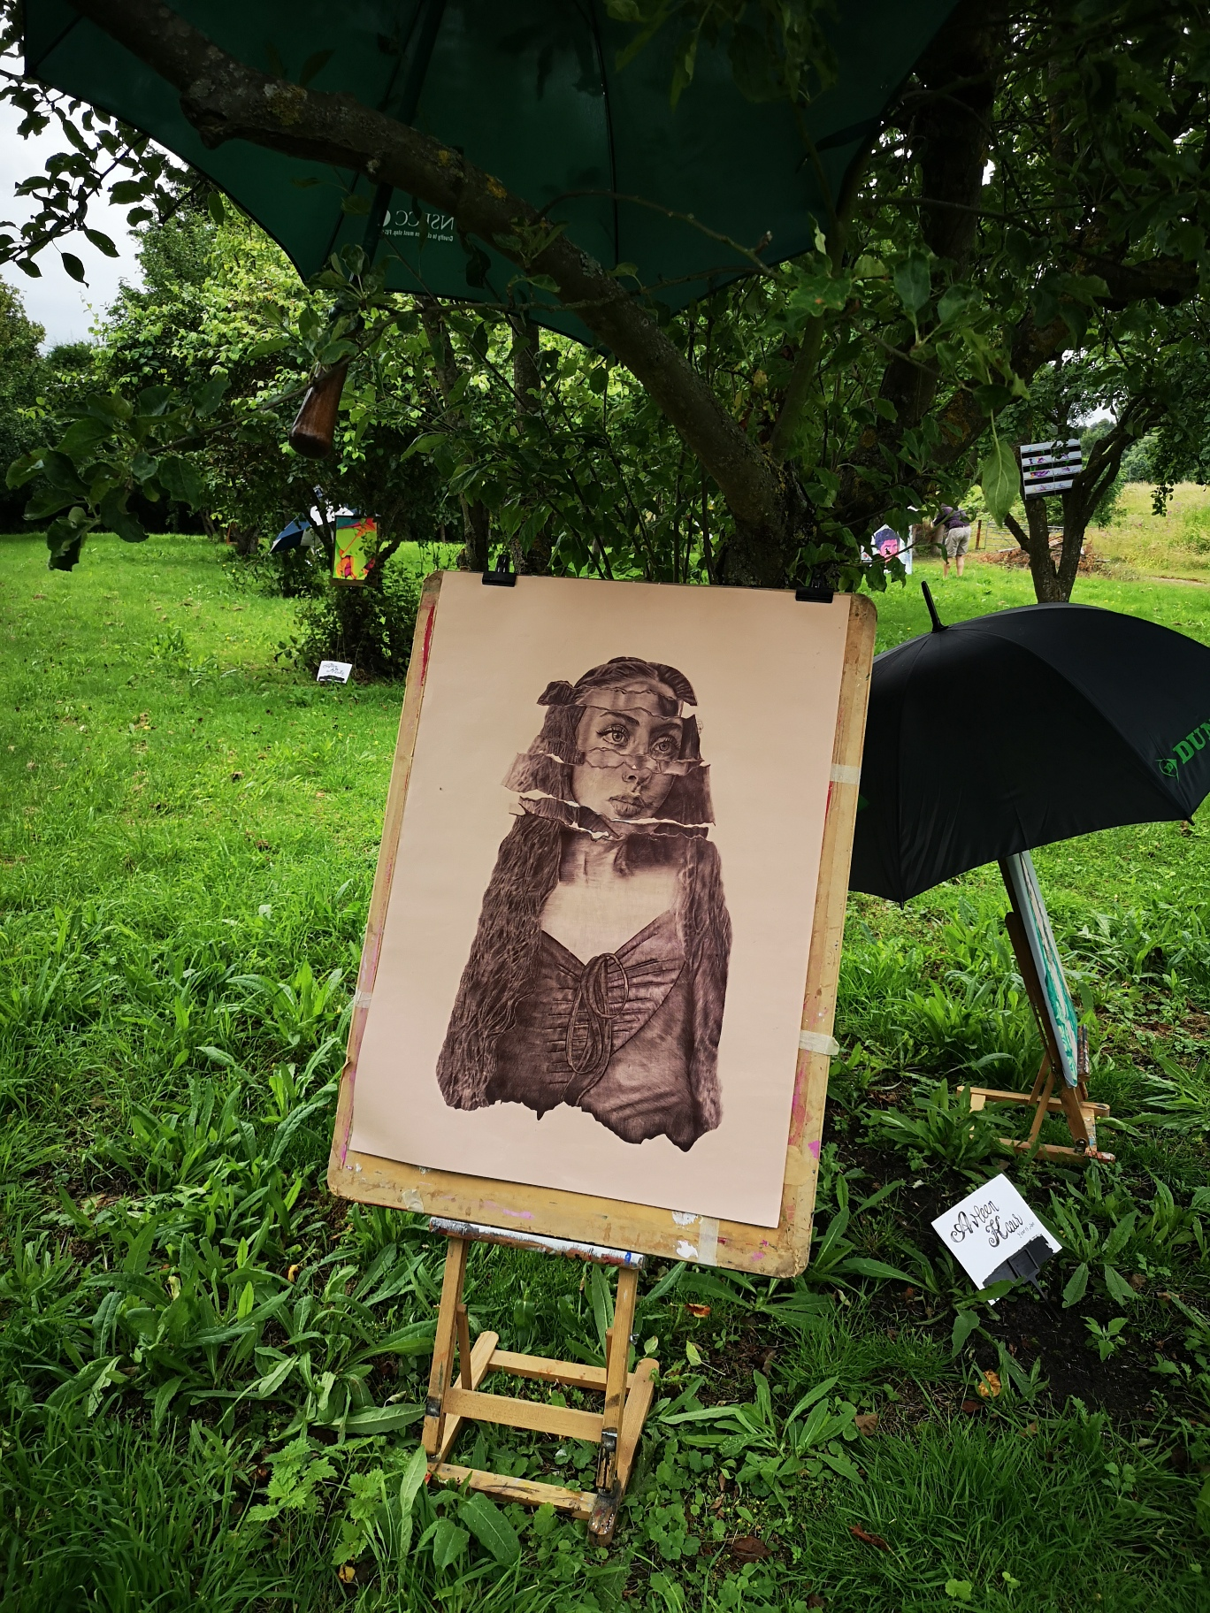

For more photos of the exhibition, please click on the below link:

<https://www.beths.bexley.sch.uk/gallery/?pid=3&gcatid=1>

**Year 10 – Honours Ties**

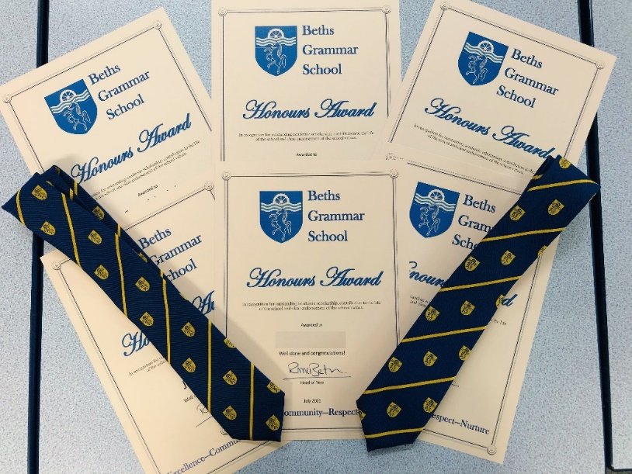Congratulations to 15 students in Year 10 who received honours ties this week for their outstanding academic scholarship and contribution to the life of the school. These students performed exceptionally well across all of their recent trial exams scoring no lower than an average grade 7. They have all worked incredibly hard this year under such difficult circumstances. The determination and positive energy we have seen from these students have been fantastic and they continue to be a great role model for other students.

The students collecting their ties and certificates as well as having some juice and biscuits with the Head of Year to celebrate their achievements. Smiles all round!

**Mr McBeth**

**Sports Day – Student Articles**

**Year 7 Sports Day 2021 by Nathan B**

The day started at 9:30 with the 200m race. From Wickham there was Will, Chiedozie and Ben. Isaac from Cray won the first race. Harvey from Hurst won the second race. Abbey won the third race. Chiedozie from Wickham won the fourth race.

Next was the 800m starting at 9:42. From Wickham there was Ivan and Joe. Daniel from Hurst won.

The 100m started at 9:50. From Wickham there was Sherif, Zion, Pascal and Beejay. Kyros from Eardley won the first race. Derrick from Eardley won the second race. Eardley won the third race. Brampton won the fourth.

300m started at 10:02. There was Daniel and Justin from Wickham. Melvin from Eardley won.

1500m starts at 10:10. From Wickham there was Leo and Henry. Leo won.

4X100m relay started at 10:20. The Wickham A team is: Zion, Pascal and Leo. B team: Will, Chiedozie, Kwadwo and Sherif. C team: Anthony, Aiden, Joe and Adam. D team: Ben, Philip and Ivan. The winner of the A team race was Eardley. The winner of the B team race was Wickham.

At 10:30 the field events started.

The winner of the Javelin (500g) was Eardley.

The winner of the discus (1kg) was Timmy from Hurst.

The winners of the tug of war were Wickham and Hurst.

Hurst won Year 7 sports day, but overall Wickham won. It was a very fun and eventful day, and I can’t wait for sports day next year.

**Year 8 Sports Day 2021 by Ewan M**

What an amazing day! The sun was shining from a clear blue sky, smiles all around and the atmosphere was thrilling and competitive. The brilliant football result with England beating Denmark the evening before definitely also raised everyone’s spirits. I don’t know about you, but my name and 7 others are under England on the MFL Euros Predictions Chart. All forms did extremely well, especially after this difficult year with lockdown and Covid-19 restrictions. My fellow students were in exceptionally great moods and everyone participating worked extremely hard to impress the audience. The battles were intense with impressive results from many participants. It was overall an enjoyable and entertaining event, as nearly all people competed in something. It was the first sports day at Beths Grammar School for our year group and I am sure we are all looking forward to the next one at the fantastic Erith Stadium.

Wickham won the Year 8 Sports Day as well as the entire school’s Sports Day. Such an incredible result. The competition was very close with Brampton and Wickham in a tie for first place with an unbelievable 678 points. Wickham ended up winning due to them having won more games. All forms did very well. Some remarkable performances were from George Nurse from 8E who soared through the air in high jump, taking the win for his form and Aiden Radley from 8W who blazed ahead of all his opponents for the whole race in the 800m. Students did their best in their activities and should feel very proud of themselves.

**The winning houses of all the Year 8 games are:**

100m = Wickham, Eardley, Wickham, Hurst 200m = Cray, Eardley, Wickham, Hurst

300m = Brampton, Wickham 800m = Wickham 1500m = Brampton

Relay A team = Eardley B team = Brampton C team = Hurst D team =Cray

Javelin = Hurst Shotput = Brampton Discus = Eardley

Triple jump = Wickham High jump = Eardley Long jump = Wickham

Tug of war

A team: Brampton V Wickham = Wickham Abbey V Eardley = Abbey Hurst V Cray = Hurst  
B team: Abbey V Hurst = Hurst Brampton V Eardley = Brampton Cray V Wickham = Cray

Sadly, someone in Year 8 fell during a 300m race and it was an intense moment for all. He later informed some people that he couldn’t feel his legs when he fell. He tried very hard to get back up and continue running. Amazing resilience and commitment from him at such a competitive moment. I hope that he is alright and feeling better.

**Now for the opinions of Mr Reason and Mr GS who were interviewed:**

**Interview No.1:**

Mr Reason, Beth's community liaison:

“How do you feel about the field events?”

*“Disappointed but not surprised.”*

“How about the running events?”

*“Fantastic. Some young students gave their lives into it. Some records.”*

“Finally, how about the tug of war?”

*“Seamless organisation.”*

“Thank you for your answers.”

**Interview No.2:**

Mr G’s, a member of staff new to the PE department:

“How do you feel about the field events?”

*“Superb. Lots of enjoyment. Lots of enthusiasm. Lots of energy.*

*Year 7 have a lot of promise with some scoring higher than year 8s.”*

“How about the running events?”

*“Very close. Unpredictable with some very good finishes.”*

“Finally, how about the tug of war?”

*“Some strong athleticism. Resilience.”*

“Thank you for your answers.”

**The scores for Year 8 Sports Day totalled are:**

Abbey=126 points Brampton=175 points Cray=159 points Eardley=160 points

Hurst=187 points Wickham 192 points

This sports day has been amazing, and I look forward for next year’s!

Thank you for reading this article and I hope you have a great day!

*If you are part of a club outside of school and participate in any competitions/challenges, please let us know – we would love to celebrate your achievements!*

*headsoffice@beths.bexley.sch.uk*

**Work Experience by Ademola, Year 11**

**NextGen Nurse – We Are People Work Experience**

Last week Thursday, I attended a work experience programme which focused on careers in nursing. The day began with all the attendees meeting the panel of nurses that offered their time for the programme. From their stories, I realised that all of them decided to be nurses for different reasons. Ranging from an internship in a psychiatric clinic, to training to be a doctor only to realise that they want to be more involved with patient care. In addition, I also learnt about the 4 different fields of nursing (adult nursing, child nursing, learning disability nursing and mental health nursing) all of which have varying responsibilities and work in different places such as house visits or even in prisons.

After this, we had a multiple choice quiz with 10 questions about the field of nursing. During this quiz we learnt some encouraging facts such as, 95% of nursing school graduates in employment within 6 months of graduation and nursing being the most trusted profession in the UK (this means people are more likely to be honest with their nurse than any other professional). It was discouraging to learn that only 10% of all professionals in nursing are males. In breakout rooms of 11 we explored potential reasons why this is happening. In my group, the discussion was centred on the media portraying the healthcare system as a field where doctors are men and nurses are women. Once we identified the issue, we brainstormed solutions such as more media projections of a balance of men and women as nurses. As well as the need for schools to encourage students by discussing careers in nursing more often.

Furthermore, we discussed the key skills required to be a nurse, these include: empathy, teamwork, communication, listening and patience, all of which are essential for being successful in any healthcare profession. We were also taught that to have a successful application into a nursing degree that work experience opportunities such as this and volunteering that exercises the skills above are pivotal.

This work experience opportunity was very enlightening for me as I didn’t know much about nursing prior to the programme. This insight into healthcare will be useful as I look further into what I want to do in the future.

*We love to hear from any of our ex-students as to what they have achieved since leaving Beths so, please do keep us updated!*

*Contact us at headsoffice@beths.bexley.sch.uk with any career updates and also photos, videos or even articles you have written about your memories of the school—we would love to share them with current staff and students.*

**The Outcome of Our Online Digital Platform Survey**

We would like to thank you for taking the time to complete the survey. Your feedback was very useful to inform us of the way forward.

**So what does the survey tell us?**

* It is clear that that both teachers and students see the benefits of the two main platforms (MS Teams and Showmyhomework) but would ideally prefer only one platform.
* Most parents/students prefer Showmyhomework for two main reasons;

1. They receive notifications.
2. They receive reminders.

These are the gaps in MS Teams at the moment.

* Teachers are divided between MS Teams and Showmyhomework and many prefer both platforms.

**The way forward**

Until MS Teams bring up a version which will address the gaps, we are proposing the following arrangement from September 2021.

**For all students**

Teachers will ensure that all homework will be set and recorded on Showmyhomework.

We will continue to deliver any remote live lessons on MS Teams.

As Showmyhomework has limited storage capacity, MS Teams will be used for storage and sharing of resources with students.

**For Key Stage 3/4 Students**

KS3/4 Students will use Showmyhomework as their main platform to upload homework. Where this is proving difficult, they can use MS Teams as a fall back option but must inform their teachers. They also use the chat/comment functionality on Showmyhomework to communicate with their teachers.

**For Key Stage 5 Students**

KS5 students/teachers can have the option to upload work/assignments on MS Teams if this is a preferred method and agreed with both parties. If a subject decides to use MS Teams then, this would be the only platform they should use to avoid confusion. Where this is not possible, students can revert back to Showmyhomework. However, all homework will still be set and recorded by teachers on Showmyhomework, even if students/teachers prefer to use MS Teams due to notifications and reminders available on Showmyhomework. Students and their teachers can also use chat on MSTeams to communicate with their teachers

**Its Learning (Old Fronter)**

This platform is less widely used compared to MS Teams and Showmyhomework. Some departments e.g Maths and Physics use it well to share resources with students. Those departments will continue to use ‘Its Learning’ for that purpose but will look at transferring them onto Teams throughout the year. We will review the whole provision again in the Spring term.

**Dates for the Diary**

|  |  |
| --- | --- |
| **Tuesday 10 August** | **A Level Results Day** |
| **Thursday 12 August** | **GCSE Results Day** |
| **Wednesday 1 September** | **Staff Only Day** |
| **Thursday 2 September** | **Staff and New Year 7 Students only** |
| **Friday 3 September** | **Staff, Year 7 and New Year 12 Students Only** |
| **Monday 6 September** | **School opens for the rest of the students** |

**Musician of the Week**

This week we are celebrating with

If you would like to be considered for Musician of the Week, please send your entries to Ms Marriott.

**Parents Association**

**Monthly Draw Winners**

**July 2021**

1. Monthly Draw -  First Prize winner of £20 - Jack in year 12.8 with winning number 203
2. Monthly Draw Second Prize winner of £10 - Ikenna in year 11H with winning number 251

**August 2021**

1. Monthly Draw  First Prize winner of £20 - Gabriel in year 8H with winning number 224
2. Monthly Draw second prize winner of £10 - Jason in year 9B winning number 53

**Fundraising campaign update!**

**Our virtual Nearly New PA Uniform Shop will open soon!**

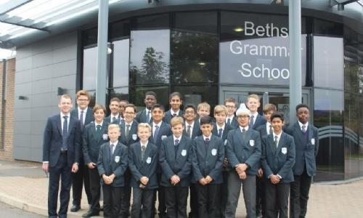 We are asking for any donations of **nearly new blazers** **and unembroidered PE kit**.  If you have any of the specified school uniform items that your son has grown out of, please do consider donating it to our PA Uniform shop ahead of our new Y7s joining us in September.

All donations can be handed in at the **School Reception marked for Beths Parents' Associations**.

We are aiming to sell these items for you to purchase once we have received donations and can provide an inventory.  If you require any items, please email the PA via [beths.parents.association@gmail.com](mailto:beths.parents.association@gmail.com).

|  |  |
| --- | --- |
|  |  |

**Our goal of raising £10,000 includes the following fantastic projects**:

* Outdoor chess tables – £2,000
* Musical instruments – £2,000
* Lighting for drama – £1,000
* Radio Beths – £5,000

**£ 10, 000**

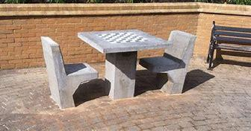**Outdoor chess tables – £2,000**

Due to the success of the online chess tournament - supporting our first of four campaigns to raise £10,000 - and easy way to get involved with the PA from the comfort of your living room, watch this space for the next tournament in **September**…!! And if you weren’t able to join the event, why not support the Beths Parents Association in raising money for the school outdoor chess tables anyway at: [**https://cafdonate.cafonline.org/16829**](https://cafdonate.cafonline.org/16829)

**Radio Beths: We aim to raise £5,000!**

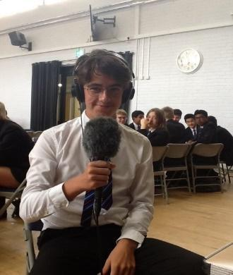We are looking to launch another ambitious project: running a school radio at Beths and encourage students to use this media channel to broaden horizons and improve cultural awareness in an inclusive environment.

By raising funds with technological resources, we can provide exciting and engaging opportunities across the curriculum.

Thank you for helping us ensure Beths students are given the best educational opportunities to develop their creativity and communication skills.

**Share the NEWS and DONATE HERE!!!!**

[**https://cafdonate.cafonline.org/17268**](https://cafdonate.cafonline.org/17268)

**Drama lighting: Help us to improve our drama studio by raising £1,000!**



We would love to provide new lights and special effects in the drama studio. With new lights, we can bring our drama lessons and smaller productions alive.

At Beths, our aim is to encourage students to engage in high quality learning experiences.

**DONATE HERE!!!!**

**https://cafdonate.cafonline.org/17269**

**Musical Instruments - £2,000**

We are very proud of Beths students who excel in the art of mastering musical instruments. The student musicians have been entertaining the Beths community via live concerts in the past as well as virtual performances during the past year and a half. It is the mission of the school to afford this opportunity to all students and therefore they require more instruments for equal opportunity for all.

Thank you for investing in this cause by using this link: [**https://cafdonate.cafonline.org/17270**](https://cafdonate.cafonline.org/17270)

**Help us raise funds at no cost for you! It is simple and quick!**

**Each week we will show you a new way of donating!**

**Generate even MORE funds for Beths Parents Association while doing your shopping**

Please go to smile.amazon.co.uk and search for Beths Parents Association. You need to start each of your shopping sessions at the **URL smile.amazon.co.uk.**

**All your support is appreciated, every pound will help us to get closer to our target goal.**



Please keep checking on our website page for upcoming events!

[Beths Grammar School - Parents Association](https://www.beths.bexley.sch.uk/page/?title=Parents+Association&pid=162)

**Careers**

**STEM & Medical Sciences Work Experience—Ages 12-18**

**’Live Online’ or In-Person at UCL**

***Architecture—Computer Science—Dentistry—Engineering—Investment Banking—Medicine—Psychology— Veterinary Medicine***

Register now for unique opportunity to work alongside experienced engineers, doctors, psychologises vets and others this term. Students can choose to attend ‘Live Online’ before Easter or in-person later in April. Our in-person events have strict COVID measures in place.

[Choose Your STEM Work Experience - InvestIN Education](https://investin.org/pages/stem)

[Choose Your Work Experience (Ages 12-14) - InvestIN Education](https://investin.org/pages/choose-your-stem-work-experience-ages-12-14)

MCG Healthcare: **'How to become a GP'**

<https://www.mcghealthcare.co.uk/blog/how-to-become-a-gp-a-career-guide/bp202/>