9th September 2024

Dear Parents/Carers,

**‘Welcome to the Sixth Form’ - An Information Evening for Parents of Yr 12 Students 6pm-7pm**

Thank you for supporting your young person in making a successful and productive start to their Sixth Form journey at Beths Grammar School. I would like to invite you to school at 5.45pm (for a prompt 6.00pm start) on Thursday 26th September.

This is your opportunity to meet with Mr Waite, Head of Year 12, Mrs Foley, Assistant Headteacher, Sixth Form and Mr Blyghton, Headteacher, alongside other members of staff that will be supporting Year 12, including their Form Tutors. There will be a talk in the school hall, where we will share with you:

* Our expectations/hopes/vision for our Sixth Form students
* How we can work together for the best outcomes for our students
* What our Sixth Form offers students
* How students can study independently effectively
* Some key dates/events during the school year
* Support for those aspiring to attend top universities and enter medicine/veterinary medicine/dentistry.

The evening is primarily designed for parents/carers, but your child is also welcome to attend, if they wish to do so.

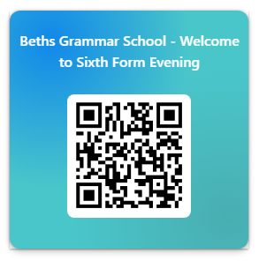I look forward to meeting with you on Thursday 26th September. Please complete the online form to indicate if you will be attending. <https://forms.office.com/e/rgYbwq90Sb>

Yours faithfully,

**Mrs Foley**

**Assistant Headteacher, Sixth Form**