**Geography Revision Skills – How to study independently effectively**

1. **Resources for Revision:**

Lesson powerpoints and handouts available on Teams

Your own notes, including HW, especially if this involved research on examples/case studies

Geography Revision Guide (e.g. Hodder)

Additional handouts, articles and website (available on Teams)

1. **General strategies for Revision:**

***2.1 Work with the information***

Condense the information from your notes and the resources above, e.g. by creating flashcards, mind maps, knowledge organiser or detailed notes, see suggestions below.

***2.2 Active Recall / Test***

One of the most crucial aspects of the revision process is ‘active recall’, where you test your memory and ability to recall and identify any gaps and misconceptions. This is done at the start at every lesson from Year 7 to Year 13, but you can also practise this on your own, for example with the help of past exam papers.

***2.3 Redo: Re-write, re-draft, revise and repeat***

Engage with feedback whether you have received teacher comments on a piece of work or are practising past exam questions and self-marking with the help of a markscheme. By actively engaging with the feedback, e.g. by re-drafting your answers, you are improving your knowledge and exam skills.

1. **Specific Revision Techniques to Try Out**

It’s important to find a revision technique that works for you. Here are some ideas that students have found work for them. The aim is to **make it stick** and then to be able to **retrieve** information in an exam situation.

***3.1 Revision cards:***

Make your own cards to cover case study details or key ideas. They should be brief and clear, including data where relevant. The back of the card can include exam questions and sample answers.

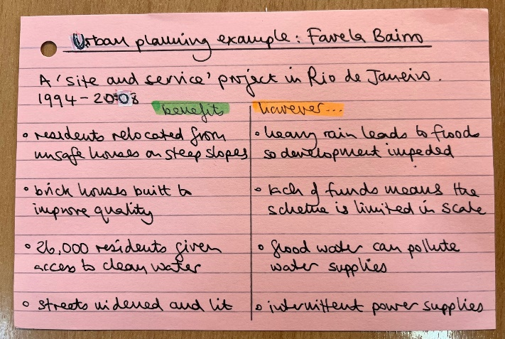

***3.2 Mind maps:***

Use topic checklists to create mind maps that cover all the key information. Using colour and drawing relevant diagrams may help information to stick.

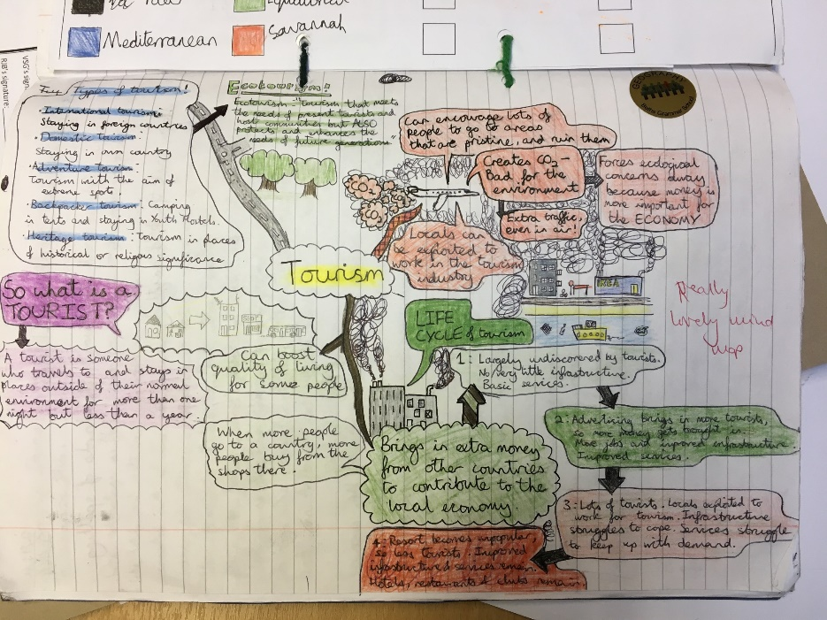

***3.3 Glossaries:***

A clear glossary of key terms you have created yourself for each topic will ensure you understand all the vocabulary that may come up, you won’t misunderstand any questions and you will be able to ‘write like a Geographer’ by actively using a wide range of key terms.

1. **Basic rules for successful learning – not just during revision:**

* Keep on top of your work, do not leave revision to the last minute, build up to it over time and you will more easily be able to retain and relay information.
* Plan your revision, create a revision timetable (backwards from your exams!), and ensure you allocate a reasonable amount of time for yourself. Research shows students often fail to do this and therefore do not stick to the timetable.
* Minimise any distractions, particularly mobile phones/television. Put your phone out of sight, e.g. in a drawer or in a different room or use apps like Flora. Research shows that even just seeing your phone without using it, occupies enough brain capacity to lower your performance in tasks such as revision or exams.
* Ensure you develop a healthy sleeping routine that fits with the school day as your brain needs “off-time” to process all the knowledge.