Term | INTENT | IMPLEMENTATION | IMPACT
 | Substantive Knowledge  Topics to be covered = subject matter to be learned.  Note we use Eduqas as out exam board.  This should be read in conjunction with the specification, which can be found here: https://www.eduqas.co.uk/umbraco/surface/blobstorage/download?nodeId=11666  Format: A1 XX = AS text book chapter XX  https://resources.eduqas.co.uk/Pages/ResourceSingle.aspx?rIid=937  Format: A2 YY = A2 text book chapter YY  https://resources.eduqas.co.uk/Pages/ResourceSingle.aspx?rIid=1179 | Disciplinary Knowledge (Skills)  Most lessons will consist of peer marking the homework from the previous lesson or a starter consisting of an exam question, theory, then practical, which may consist of computer simulation or building circuits in real life. At the end of each topic there will be a formal end of unit test.  SEE BELOW FOR A MUCH MORE DETAILED VERSION | Assessment opportunities  Students will be assessed on homework marks, end of unit tests and trail exams.
The timetable below is based on the 2023/5 lesson planned sequence and is subject to change.
Year 12 Autumn 1 | Intro to Electronics. Some material from the A1 Core Concepts and A1 01s chapters will be covered https://resource.download.wjec.co.uk/vtc/2016-17/16-17_1-9/gce-electronics-book-core-concepts.pdf  gce-electronics-book-chapter-1.pdf (wjec.co.uk)
A1 05 Semiconductor components
gce-electronics-book-chapter-5.pdf (wjec.co.uk)
A1 02 Logic systems
gce-electronics-book-chapter-2.pdf (wjec.co.uk)
Autumn 2 | A1 02 Timing Circuits  gce-electronics-book-chapter-3.pdf (wjec.co.uk)
A1 03 Sequential Logic Systems
gce-electronics-book-chapter-3.pdf (wjec.co.uk)
A1 04 Operational Amplifiers
gce-electronics-book-chapter-4.pdf (wjec.co.uk)
Spring 1 | A1 04 Operational Amplifiers continued  gce-electronics-book-chapter-4.pdf (wjec.co.uk)
A1 06 Microcontrollers (Physical computing using flowchart interpreter)
gce-electronics-book-chapter-6.pdf (wjec.co.uk)
Spring 2 | A1 07 Mains Power Supplies  gce-electronics-book-chapter-7.pdf (wjec.co.uk)
A2 01 Further Sequential Logic Systems
gce-electronics-book-chapter-1.pdf (wjec.co.uk)
Summer 1 | A2 04 AC Circuits  gce-electronics-book-chapter-4.pdf (wjec.co.uk)
A2 05 Signal conversion (Analogue to digital conversion)
gce-electronics-book-chapter-5.pdf (wjec.co.uk)
Summer 2 | A2 09 Communications systems (intro to sending data long distance)  gce-electronics-book-chapter-9.pdf (wjec.co.uk)
A2 02 Further Mains Power Supplies
gce-electronics-book-chapter-2.pdf (wjec.co.uk)
A2 08 High Power Switching Systems
gce-electronics-book-chapter-8.pdf (wjec.co.uk)
Year 13 Autumn 1 | Start of year test  Past papers AS and A Level Electronics | Eduqas
A2 10 Wireless Transmission (Intro to radio communications)
gce-electronics-book-chapter-10.pdf (wjec.co.uk)
A2 07 Instrumentation Systems (differential op amps, encoders and strain gauges)
gce-electronics-book-chapter-7.pdf (wjec.co.uk)
A2 11 Digital Communications (Intro to data links)
gce-electronics-book-chapter-11.pdf (wjec.co.uk)
A2 12 Optical Communications (Intro to fibre optic communications)
gce-electronics-book-chapter-12.pdf (wjec.co.uk)
Autumn 2 | A2 06 Audio Systems  gce-electronics-book-chapter-6.pdf_(wjec.co.uk)
A2 03 Further Microcontrollers (assembly language physical computing)
gce-electronics-book-chapter-3.pdf (wjec.co.uk)
A2 13 Further Semiconductors (how PN junctions & FETs work)
gce-electronics-book-chapter-13.pdf (wjec.co.uk)
 | Assembly language coursework (NEA 1)
Spring 1 | Main project (NEA 2)
Spring 2 | Main project (NEA 2) continued |  | As above
Easter 1 | NEA 1 & 2 hand in
 | Revision
Easter 2 | Revision
 | Exams

Term | INTENT | IMPLEMENTATION | IMPACT
 | Substantive Knowledge  Topics to be covered = subject matter to be learned.  Note we use Eduqas as out exam board.  This should be read in conjunction with the specification, which can be found here: https://www.eduqas.co.uk/umbraco/surface/blobstorage/download?nodeId=11666  Format: A1 XX = AS text book chapter XX  https://resources.eduqas.co.uk/Pages/ResourceSingle.aspx?rIid=937  Format: A2 YY = A2 text book chapter YY  https://resources.eduqas.co.uk/Pages/ResourceSingle.aspx?rIid=1179 | Disciplinary Knowledge (Skills)  Most lessons will consist of peer marking the homework from the previous lesson or a starter consisting of an exam question, theory, then practical, which may consist of computer simulation or building circuits in real life. At the end of each topic there will be a formal end of unit test.  This document has been produced in two lengths at the request of Beths’ leadership team. The first is the short version with links to the chapters and the specification.  The second is the same document with the key passages from the specification cut, pasted and formatted to fit.  I would be interested to find out which version is most useful to you – please do email me at mrmorgan AT beths.bexley.sch.uk | Assessment opportunities  Students will be assessed on homework marks, end of unit tests and trail exams.
The timetable below is based on the 2023/5 lesson planned sequence and is subject to change.
Year 12 Autumn 1 | Intro to Electronics. Some material from the A1 Core Concepts and A1 01s chapters will be covered https://resource.download.wjec.co.uk/vtc/2016-17/16-17_1-9/gce-electronics-book-core-concepts.pdf  gce-electronics-book-chapter-1.pdf (wjec.co.uk)  This first unit in Year 12 builds from the prior knowledge from the work covered in Year 11 in the ‘Electricity’ module and enable students to build a step-by-step approach to more complex systems  At the end of this topic you should be able to:  • recognise that electronic systems are assembled from sensing, processing and output sub-systems;  • state the need for and use driver sub-systems;  • design, analyse or modify a block diagram of a system. | distinguish between electrical charge, current and voltage;  • distinguish between energy supplied and power rating;  • recall and use the formula: P=I × V;  • distinguish between conductors, insulators and semiconductors in terms of their electrical conduction properties; • distinguish between series and parallel connections;  • recall that ammeters are connected in series with the component under investigation, that voltmeters are connected in parallel with the component under investigation and that multimeters combine the functions of ammeter and voltmeter | Weekly homework  Past paper questions as starters  Classwork Marked  Peer and self-assessment  End of unit tests for chapter
 | A1 05 Semiconductor components  gce-electronics-book-chapter-5.pdf (wjec.co.uk) | 1. SEMICONDUCTOR COMPONENTS  Overview  This topic covers the construction of semiconductors in terms of n-type and p-type  materials and the processes at a p-n junction and looks at the use of a range of  diodes and transistors.  Electronic skills  The topic gives learners the opportunity to explore the action of several types of  diodes and npn bipolar and MOSFET transistors. Learners will also work with  various semiconductor devices and calculate values using component data and  graphs.  Mathematical skills  There are a number of opportunities for the development of mathematical skills in this  topic. These include: recognising and using expressions in decimal and standard  form; estimating results; using an appropriate number of significant figures; changing  the subject of an equation; and translating information between graphical, numerical  and algebraic forms.  Learners should be able to:  (a) recall the conduction processes in n- and p-type semiconductors in terms of  electrons and holes  (b) recall conduction processes at a p-n junction, the reasons for the difference in  the conducting properties of a p-n diode in the different directions and explain  the operation of an LED  (c) recall the principles of operation of a photodiode  (d) explain the properties of an n-channel enhancement mode MOSFET in terms  of the effects of bias voltage on the conducting channel (pinching)  (e) describe the use of light-emitting diodes, silicon diodes and zener diodes in  electronic systems and using data, including interpreting and sketching  characteristic graphs to carry out relevant calculations on circuits containing  these devices  (f) calculate series resistor values for LED circuits and select appropriate zener  diodes  (g) describe the use of n-channel enhancement mode MOSFETs and npn bipolar  transistors in switching circuits, using data to select suitable components for  circuits  (h) define gM as the gradient of an ID-VGS graph.  (i) select and apply the equations  IC . hFE.IB bipolar transistor  D M GS I . g (V .3) MOSFET  2  D DSon P . I r power dissipated in a MOSFET. | Weekly homework  Past paper questions as starters  Classwork Marked  Peer and self-assessment  End of unit tests for chapter
 | A1 02 Logic systems  gce-electronics-book-chapter-2.pdf (wjec.co.uk) | 2. LOGIC SYSTEMS  Overview  This topic involves the study of logic gates in control. Learners will look at the types  of logic gates and their function, develop combinations of logic gates to perform other  logic functions and to solve set tasks. Methods for simplifying logic systems will also  be developed.  Electronic skills  This topic involves learners exploring the use of logic to control systems. Learners  will work with different types of logic gates, understand how to connect and combine  them to create different functions. They will use several methods to examine the  workings of logic systems and be able to simplify these systems.  Mathematical skills  There are a number of opportunities for the development of mathematical skills in this  topic. These include: recognising and using expressions in Boolean algebra;  simplifying logic systems using Boolean algebra, Karnaugh maps and multiplexers;  and translating information between graphical, numerical and algebraic forms.  Learners should be able to:  (a) identify and use NOT; 2 and 3-input AND, NAND, OR, NOR, XNOR and XOR  logic gates  (b) construct, recognise and use truth tables for these gates and simple  combinations of them  (c) use combinations of one or more types of gate to perform other logic functions  including NAND-gate simplification  (d) simplify logic systems using Boolean algebra, Karnaugh maps and  multiplexers  (e) design and construct circuits containing logic gates, with consideration to  sourcing, sinking, pull-up and pull-down resistors  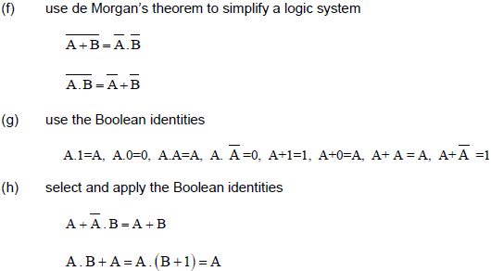 | Weekly homework  Past paper questions as starters  Classwork Marked  Peer and self-assessment  End of unit tests for chapter
Autumn 2 | A1 02 Timing Circuits  gce-electronics-book-chapter-3.pdf (wjec.co.uk) | TIMING CIRCUITS  Overview  This topic develops the use of RC circuits to create time delays and their use in the  creation of mono and astable timing circuits.  Electronic skills  This topic gives learners the opportunities to explore the charging and discharging of  a RC network and its application in debouncing switches. Learners also investigate  the operation of a 555 timer IC in monostable and astable circuits through  calculation, modelling and simulation. They will also study astable circuits based  upon Schmitt triggers.  Mathematical skills  There are a number of opportunities for the development of mathematical skills in this  topic. These include: recognising and using expressions in decimal and standard  form; using an appropriate number of significant figures; changing the subject of an  equation; substituting numerical values into algebraic equations using appropriate  units for physical quantities; using calculators to find and use power, exponential and  logarithmic functions; solving simple algebraic equations; translating information  between graphical, numeric and algebraic form; plotting two variables from  experimental or other data; interpreting and plotting logarithmic plots; interpret data  presented in graphical form; and changing the subject of an equation.  Learners should be able to:  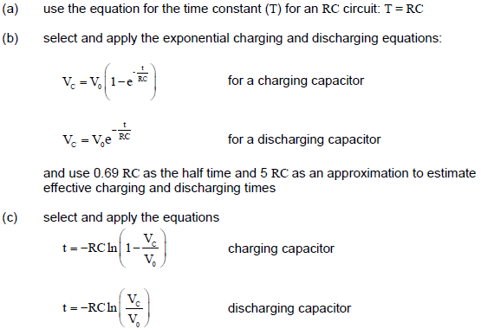d) calculate values of T, R and C for a charging / discharging capacitor by using  a graph (including log graphs)  (e) use a RC circuit in debouncing switches  (f) recall the properties of monostable circuits  (g) explain the use of a monostable circuit in conjunction with a RC network in a  time-delay circuit  (h) recall the properties of an astable circuit and its use as a pulse generator  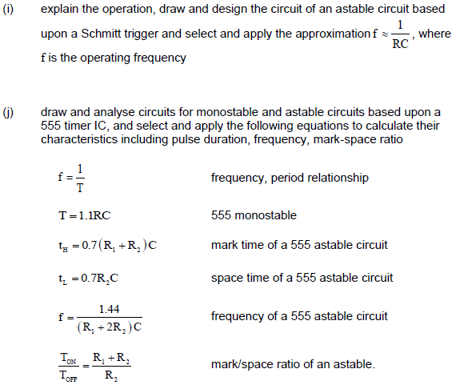 | Weekly homework  Past paper questions as starters  Classwork Marked  Peer and self-assessment  End of unit tests for chapter
 | A1 03 Sequential Logic Systems  gce-electronics-book-chapter-3.pdf (wjec.co.uk) | OPERATIONAL AMPLIFIERS  Overview  This topic develops the uses of operational amplifiers (op-amps) and how they can  be connected for different purposes. It involves the study of gain and outputs  calculated from different inputs and resistor values and looks at bandwidth, distortion  and slew-rate.  Electronic skills  This topic gives learners the opportunity to explore the different types of op-amps  through modelling or simulation and to compare results to expected estimations and  calculated results.  Mathematical skills  There are a number of opportunities for the development of mathematical skills in this  topic. These include: recognising and using expressions in decimal and standard  form; understanding and using the symbols: =,<,<<,>>,>,˜,.; estimating results;  using an appropriate number of significant figures; making order of magnitude  calculations; translating information between graphical and numerical form;  interpreting data presented in graphical form; and changing the subject of an  equation.  Learners should be able to:  (a) recall the characteristics of an ideal op-amp and be aware that these may be  different for a typical op-amp  (b) recognise that the voltage difference between the two inputs of an op-amp  with negative feedback is virtually zero (resulting in a virtual earth if one of the  inputs is at 0 V) provided the output is not saturated  (c) explain the use of an op-amp in a comparator circuit  (d) recall how the output state of a comparator depends upon the relative values  of the two input states and design comparator switching circuits  (e) recall and apply the conditions for the balance of a bridge circuit  and apply the equation  (g) draw, recognise and recall the characteristics of the following op-amp circuits:  . non-inverting amplifier  . inverting amplifier  . summing amplifier  . comparator  . voltage follower circuit  (h) select and apply the following equations for op-amp circuits:  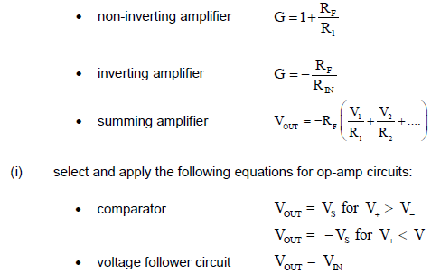(j) relate the input impedance of an op-amp to its configuration  (k) recall that the bandwidth is the frequency range over which the voltage gain is  frequency response curve and use the gain-bandwidth product (unity gain  bandwidth) to estimate bandwidth  (l) design single stage amplifiers based on inverting and non-inverting voltage  amplifiers to achieve a specified voltage gain or bandwidth;  (m) explain how clipping and slew-rate can lead to distortion  (n) select and apply the equations  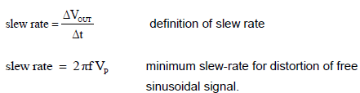 | Weekly homework  Past paper questions as starters  Classwork Marked  Peer and self-assessment  End of unit tests for chapter
 | A1 04 Operational Amplifiers  gce-electronics-book-chapter-4.pdf (wjec.co.uk) | OPERATIONAL AMPLIFIERS  Overview  This topic develops the uses of operational amplifiers (op-amps) and how they can  be connected for different purposes. It involves the study of gain and outputs  calculated from different inputs and resistor values and looks at bandwidth, distortion  and slew-rate.  Electronic skills  This topic gives learners the opportunity to explore the different types of op-amps  through modelling or simulation and to compare results to expected estimations and  calculated results.  Mathematical skills  There are a number of opportunities for the development of mathematical skills in this  topic. These include: recognising and using expressions in decimal and standard  form; understanding and using the symbols: =,<,<<,>>,>,˜,.; estimating results;  using an appropriate number of significant figures; making order of magnitude  calculations; translating information between graphical and numerical form;  interpreting data presented in graphical form; and changing the subject of an  equation.  Learners should be able to:  (a) recall the characteristics of an ideal op-amp and be aware that these may be  different for a typical op-amp  (b) recognise that the voltage difference between the two inputs of an op-amp  with negative feedback is virtually zero (resulting in a virtual earth if one of the  inputs is at 0 V) provided the output is not saturated  (c) explain the use of an op-amp in a comparator circuit  (d) recall how the output state of a comparator depends upon the relative values  of the two input states and design comparator switching circuits  (e) recall and apply the conditions for the balance of a bridge circuit  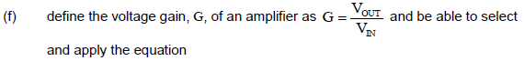  (g) draw, recognise and recall the characteristics of the following op-amp circuits:  . non-inverting amplifier  . inverting amplifier  . summing amplifier  . comparator  . voltage follower circuit  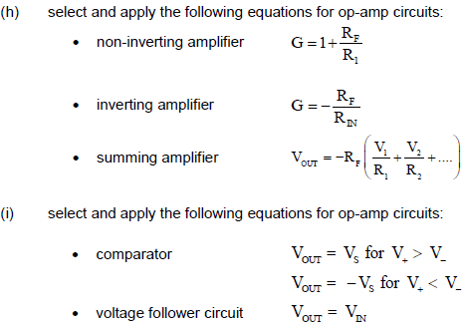(j) relate the input impedance of an op-amp to its configuration  (k) recall that the bandwidth is the frequency range over which the voltage gain is  frequency response curve and use the gain-bandwidth product (unity gain  bandwidth) to estimate bandwidth  (l) design single stage amplifiers based on inverting and non-inverting voltage  amplifiers to achieve a specified voltage gain or bandwidth;  (m) explain how clipping and slew-rate can lead to distortion  (n) select and apply the equations  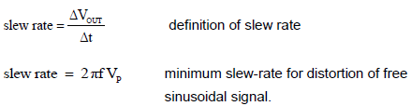 | Weekly homework  Past paper questions as starters  Classwork Marked  Peer and self-assessment  End of unit tests for chapter
Spring 1 | A1 04 Operational Amplifiers continued  gce-electronics-book-chapter-4.pdf (wjec.co.uk) | As above
 | A1 06 Microcontrollers (Physical computing using flowchart interpreter)  gce-electronics-book-chapter-6.pdf (wjec.co.uk) | MICROCONTROLLERS  Overview  This topic covers the microcontroller as a programable integrated circuit (PIC) and its  internal structure. It also covers how microcontrollers are interfaced and programed  through flowcharts and assembler language to perform tasks.  Electronic skills  Learners will have the opportunity in this topic to work with microcontrollers,  interfacing them to inputs and outputs and programing them to perform set tasks.  Learners will also use both flowcharts and assembler language to program the  microcontrollers and look at the application of microcontrollers.  Mathematical skills  There are some opportunities for the development of mathematical skills in this topic.  These include: converting between binary and decimal number systems; and drawing  and interpreting flowcharts.  Learners should be able to:  (a) analyse and design flowchart programs to program microcontrollers  (b) recall and describe the structure of a PIC microcontroller as programmable  assemblies of memory, input ports, output ports, CPU, clock and reset  (c) recall and explain the use of interrupts to allow an external device to be  serviced on request  (d) recall and describe the application of a PIC microcontroller  (e) analyse, design and program PIC microcontroller-based circuits using  assembler language. | Weekly homework  Past paper questions as starters  Classwork Marked  Peer and self-assessment  End of unit tests for chapter
Spring 2 | A1 07 Mains Power Supplies  gce-electronics-book-chapter-7.pdf (wjec.co.uk) | MAINS POWER SUPPLY SYSTEMS  Overview  This topic explores power supplies with half and full wave rectification, the use of  capacitors and load and line regulation. The topic also involves the analysis and  design of regulators based upon a zener diode, a transistor emitter follower and a  non-inverting amplifier.  Electronic skills  This topic gives learners opportunities to model and simulate half and full wave  rectification, by examining the effect of capacitors and loads on the output of simple  power supplies. Learners have the opportunity to construct and test a range of  voltage regulators consisting of a zener diode, a transistor emitter follower or noninverting  amplifier.  Mathematical skills  There are a number of opportunities for the development of mathematical skills in this  topic. These include: recognising and using expressions in decimal and standard  form; using an appropriate number of significant figures; making order of magnitude  calculations; changing the subject of an equation; translating information between  graphical and numerical form; and interpreting data presented in graphical form.  Learners should be able to:  (a) recall the use of diodes for half-wave and full wave rectification  (b) describe the effect of capacitors and loads on the output of a simple power  supply  (c) select and apply the ripple voltage equation  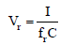  (d) design zener regulated power supplies and draw graphs to show the effect of  loading  (e) distinguish between load regulation and line regulation  (f) analyse and design a voltage regulator based upon a zener diode, a transistor  emitter follower and a non-inverting amplifier  (g) select and apply the gain equation  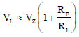 | Weekly homework  Past paper questions as starters  Classwork Marked  Peer and self-assessment  End of unit tests for chapter
 | A2 01 Further Sequential Logic Systems  gce-electronics-book-chapter-1.pdf (wjec.co.uk) | SEQUENTIAL LOGIC SYSTEMS  Overview  This topic covers latches based on NAND gates and propagation delays in sequential  systems. It involves the study of characteristics and uses for a range of systems  based on D-type flip-flops, dedicated 4-bit counters, 2 digit decimal counter and  synchronous counter systems.  Electronic skills  This topic expands on the logic systems topic, which gives learners further  opportunities to design and analyse sequential logic systems. Learners will also  explore a range of uses for D-type flip-flops.  Mathematical skills  There are a number of opportunities for the development of mathematical skills in this  topic. These include: recognising and using expressions in Boolean algebra;  simplifying logic systems using Boolean algebra, Karnaugh maps and multiplexers;  translating information between graphical, numerical and algebraic forms,  constructing and using timing diagrams; and converting between binary, decimal,  hexadecimal and binary-coded decimal (BCD) number systems.  Learners should be able to:  (a) design and describe the action of a Set-Reset (SR ) latch based on NAND  gates  (b) describe the significance of propagation delays in sequential systems  (c) construct and use timing diagrams to explain the operation of sequential logic  circuits  (d) recall the characteristics and uses of the inputs and outputs of D-type flipflops  for:  . transition gates  . frequency divider circuits  . asynchronous counters  . parallel-in-series-out (PISO) registers  . series-in-parallel-out (SIPO) registers  . synchronous counters  (e) design systems that use a dedicated 4-bit counter and combinational logic to  produce a sequence of events  (f) design and analyse a 2 digit decimal counting system  (g) convert between binary, decimal, hexadecimal and binary-coded decimal  (BCD) number systems  (h) design sequence generators based on D-type flip-flops configured as  synchronous counters, use state diagrams and explain the significance of  stuck and unused states, including Boolean manipulation to produce simpler  solutions. | Weekly homework  Past paper questions as starters  Classwork Marked  Peer and self-assessment  End of unit tests for chapter
Summer 1 | A2 04 AC Circuits  gce-electronics-book-chapter-4.pdf (wjec.co.uk) | AC CIRCUITS AND PASSIVE FILTERS  Overview  This topic involves the study of resistive loads for AC circuits and impedance to  passive filters. High-pass and low-pass passive RC filters and passive LC band-pass  filters are also included.  Electronic skills  This topic allows learners to explore the use of capacitors and inductors in AC  circuits and their use to form filters. Filters are further investigated to see how they  can be adapted for different uses.  Mathematical skills  There are a number of opportunities for the development of mathematical skills in this  topic. These include: recognising and using expressions in decimal and standard  form; calculating squares and square roots; using an appropriate number of  significant figures; making order of magnitude calculations; understanding and using  the symbols =, p; changing the subject of an equation; substituting numerical values  into algebraic equations using appropriate units for physical quantities; finding  arithmetic means; translating information between graphical and numeric form;  plotting two variables from experimental or other data; interpreting and plotting  logarithmic plots; and interpreting data presented in graphical form.  Learners should be able to:  (a) use V-t, I-t and P-t graphs for resistive loads  (b) describe the relationship between rms and peak values  (c) select and apply the equations to calculate the reactance of capacitors and  inductors and the impedance for a series circuit  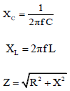  (d) draw, recognise and interpret the output of RC passive filters using linear-log  and log-log output graphs and describe the advantage of buffering passive  filters  (e) recognise, analyse, design and draw circuits for high-pass and low-pass  passive RC filters and passive LC band-pass filters  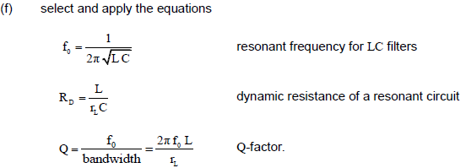 | Weekly homework  Past paper questions as starters  Classwork Marked  Peer and self-assessment  End of unit tests for chapter
 | A2 05 Signal conversion (Analogue to digital conversion)  gce-electronics-book-chapter-5.pdf (wjec.co.uk) | SIGNAL CONVERSION  Overview  This topic will cover the need for signal conversion and investigate the design and  use of both digital to analogue and analogue to digital signal conversion subsystems.  Electronic skills  This topic allows learners to explore the conversion of digital to analogue signals and  analogue to digital signals by using operational amplifiers. ADC converters are  further investigated to look at flash and digital ramp ADCs.  Mathematical skills  There are some opportunities for the development of mathematical skills in this topic.  These include: recognising and using expressions in decimal and standard form;  estimating results; using an appropriate number of significant figures; and changing  the subject of an equation.  Learners should be able to:  (a) explain the need for signal conversion between analogue and digital form in  communications and microprocessors  (b) describe how an op-amp summing amplifier can be used as a DAC to convert  a digital signal into an analogue signal  (c) analyse and design a DAC based upon an op-amp summing amplifier to meet  a given specification  (d) describe how comparators can be used as an ADC to convert an analogue  signal into a digital signal  (e) describe the process of digitising audio signals and explain the effects of  sampling rate and resolution  (f) analyse and design a flash converter ADC based on comparators and priority  encoders to meet a specification and describe the factors affecting the  resolution  (g) select and apply the equation for calculating the resolution of a n-bit flash  Converter  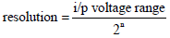  (h) compare the difference of a digital ramp ADC and a flash ADC. | Weekly homework  Past paper questions as starters  Classwork Marked  Peer and self-assessment  End of unit tests for chapter
Summer 2 | A2 09 Communications systems (intro to sending data long distance)  gce-electronics-book-chapter-9.pdf (wjec.co.uk) | COMMUNICATIONS SYSTEMS  Overview  This topic involves the study of communication systems and provides a basic  understanding of communication systems to develop in wireless transmission, digital  communication and optical communication topics.  Electronic skills  This topic allows learners to explore communications systems. Learners will look at  the concept of communication and the structure of communication systems. This  progresses to exploring data transmission through calculation of bandwidth, data rate  and gain. Learners will also be introduced to the concepts of noise and distortion.  Mathematical skills  There are some opportunities for the development of mathematical skills in this topic.  These include: translating information between graphical and numeric form; changing  the subject of an equation; substituting numerical values into algebraic equations;  using decibel notation and logarithmic functions; using appropriate units for physical  quantities; and interpreting data presented in graphical form.  Learners should be able to:  (a) recall that communication is the transfer of meaningful information from one  location to another  (b) recall the structure of a simple communication system consisting of:  information source, transmitter/encoder, transmission medium,  amplifier/regenerator receiver/decoder and information destination  (c) recall and explain the relationship between bandwidth, data rate and  information-carrying capacity and select and apply the equations  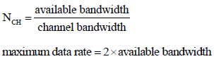(d) explain the need to multiplex a number of signals onto one transmission  medium and describe the principles of frequency and time division  multiplexing  (e) describe the role of filters in communication systems  (f) use the decibel scale to express power gain in amplifiers/attenuation in  transmission media and select and apply the equation  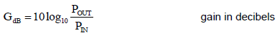(g) differentiate between noise and distortion  (h) calculate the total gain in a communication system given the power gain or  attenuation of its component parts  (i) state what is signal to noise ratio and select and apply the equations  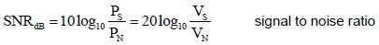(j) state what signal attenuation is and describe the significance of signal  attenuation (in dB) for the signal-to-noise ratio. | Weekly homework  Past paper questions as starters  Classwork Marked  Peer and self-assessment  End of unit tests for chapter
 | A2 02 Further Mains Power Supplies  gce-electronics-book-chapter-2.pdf (wjec.co.uk) | Continuation of Mains Power Supplies | Weekly homework  Past paper questions as starters  Classwork Marked  Peer and self-assessment  End of unit tests for chapter
 | A2 08 High Power Switching Systems  gce-electronics-book-chapter-8.pdf (wjec.co.uk) | HIGH POWER SWITCHING SYSTEMS  Overview  This topic involves the study of high power switching for both DC/AC loads. It covers  the use and application of thyristors, diacs and triacs for high power switching.  Electronic skills  This topic gives opportunities for learners to model and simulate switching circuits for  both DC and AC systems.  Mathematical skills  There are a number of opportunities for the development of mathematical skills in this  topic. These include: recognising and using expressions in decimal and standard  form; using calculators to find and use power, exponential and tan functions;  estimating results; using an appropriate number of significant figures; making order of  magnitude calculations; changing the subject of an equation; translating information  between graphical and numerical form; and interpret data presented in graphical  form.  Learners should be able to:  (a) describe the advantages of using thyristors and triacs to switch high power  DC/AC loads respectively, compared to using a transistor or a relay  (b) recall the general thyristor characteristics, the conditions under which a  thyristor conducts and explain the significance of the following terms:  holding current, minimum gate voltage, minimum gate current  (c) design DC thyristor switching circuits and explain the process of capacitor  commutation  (d) draw the circuit diagram and analyse graphs for an AC phase control circuit,  using a RC network, a triac and a diac  (e) select and apply the equation  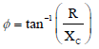  to calculate the phase shift between supply voltage and capacitor voltage. | Weekly homework  Past paper questions as starters  Classwork Marked  Peer and self-assessment  End of unit tests for chapter
Year 13 Autumn 1 | Start of year test  Past papers AS and A Level Electronics | Eduqas |  | Informs UCAS predicted grades
 | A2 10 Wireless Transmission (Intro to radio communications)  gce-electronics-book-chapter-10.pdf (wjec.co.uk) | WIRELESS TRANSMISSION  Overview  This topic covers the principles of wireless transmission including amplitude  modulation (AM) and frequency modulation (FM).  Electronic skills  This topic gives learners the opportunity to explore wireless transmission, including  the radio spectrum for data transmission, bandwidth requirements and available  frequency channels. Learners will also perform calculations on the different types of  modulation.  Mathematical skills  There are a number of opportunities for the development of mathematical skills in this  topic. These include: recognising and using expressions in decimal and standard  form; understanding and using the symbols =,.; substituting numerical values into  algebraic equations; using appropriate units for physical quantities; solving simple  algebraic equations; estimating results; using an appropriate number of significant  figures; making order of magnitude calculations; translating information between  graphical and numerical form; interpreting data presented in graphical form; and  changing the subject of an equation.  Learners should be able to:  (a) recall and explain the use of the different regions of the radio spectrum for the  transmission of data, including in terms of bandwidth requirements and  available frequency channels  (b) describe and explain the use of amplitude modulation and frequency  modulation and select and apply the equations  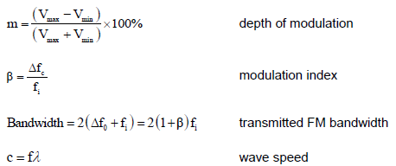(c) sketch, recognise and analyse the resulting waveforms for a sinusoidal carrier  being amplitude and frequency modulated by a single frequency audio signal. | Weekly homework  Past paper questions as starters  Classwork Marked  Peer and self-assessment  End of unit tests for chapter
 | A2 07 Instrumentation Systems (differential op amps, encoders and strain gauges)  gce-electronics-book-chapter-7.pdf (wjec.co.uk) | INSTRUMENTATION SYSTEMS  Overview  This topic draws together the use of op-amps for instrumentation systems, the use of  bridge circuits with thermistors and strain gauges in instrumentation and the use of  slotted and encoded discs.  Electronic skills  This topic enables learners to further explore the op-amp difference amplifier for  instrumentation and the use of bridge circuits with thermistors and strain gauges.  Learners also investigate methods of sensing rotational speed and angular position  using slotted and encoded discs.  Mathematical skills  There are a number of opportunities for the development of mathematical skills in this  topic. These include: recognising and using expressions in decimal form; using  appropriate number of significant figures; changing the subject of an equation;  substituting numerical values into algebraic equations using appropriate units for  physical quantities; translating information between graphical and numeric form; and  interpreting data presented in graphical form.  Learners should be able to:  (a) draw and recognise an op-amp difference amplifier circuit and select and  apply the equation  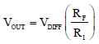  (b) analyse and design instrumentation amplifiers based upon the op-amp  difference amplifier circuit  (c) describe the use of bridge circuits with thermistors and strain gauges  (d) describe the use of the slotted discs (for sensing rotational speed) and  encoded discs (for sensing angular position)  (e) compare the Gray coding of encoded discs with binary coding  (f) design logic system to process the output of slotted and encoded discs. | Weekly homework  Past paper questions as starters  Classwork Marked  Peer and self-assessment  End of unit tests for chapter
 | A2 11 Digital Communications (Intro to data links)  gce-electronics-book-chapter-11.pdf (wjec.co.uk) | DIGITAL COMMUNICATIONS  Overview  This topic develops the concepts of digital communication by examining different  types of modulation and the regeneration of digital signals. Block diagrams of pulse  code modulation (PCM) systems are used to explain their operation. Also Nyquist  theorem and time division multiplexing (TDM) is introduced.  Electronic skills  This topic enables learners to explore the construction of systems required for digital  communications. They will also have opportunity to explore parts of digital  communication systems.  Mathematical skills  There are some opportunities for the development of mathematical skills in this topic.  These include: translating information between graphical and numeric form; plotting  two variables from data; and interpreting data presented in graphical form  Learners should be able to:  (a) analyse and design Schmitt trigger circuits to regenerate a digital signal  (b) analyse and draw graphs to illustrate pulse modulation techniques (pulse  width modulation (PWM), pulse amplitude modulation (PAM), pulse position  modulation (PPM))  (c) draw a block diagram for and describe the operation of a pulse code  modulation (PCM) communication system consisting of:  transmitter  low pass filter, sampling gate, sampling clock, ADC, PISO shift register,  PISO clock  and receiver  Schmitt trigger, SIPO shift register, SIPO clock, DAC, low pass filter  (d) use the relationship between required sampling frequency to the highest  frequency in the signal and Nyquist theorem  (e) describe how time division multiplexing (TDM) can be used to improve the  user capacity of a PCM communications link  (f) state the limitation on the number of channels that can be incorporated into a  PCM communications link, using TDM and use given data to calculate how  many channels can be incorporated into a PCM communications link, using  TDM. | Weekly homework  Past paper questions as starters  Classwork Marked  Peer and self-assessment  End of unit tests for chapter
 | A2 12 Optical Communications (Intro to fibre optic communications)  gce-electronics-book-chapter-12.pdf (wjec.co.uk) | OPTICAL COMMUNICATION  Overview  This topic introduces the principles of optical communication, its limitations and the  principles for converting between electrical and optical signals.  Electronic skills  Learners will have the opportunity to study optical communications, with practical  opportunities to explore basic circuits for converting between electrical and optical  signals by modelling the systems.  Learners should be able to:  (a) describe how the refractive properties of glass allow signals to be transmitted  over long distances in optical fibres  (b) describe the effects of dispersion, attenuation and radiation losses in optical  fibre communication and the relative advantages of single and multi-mode  optical fibres in a communication network  (c) describe the principles of operation of circuits for converting between  electrical and optical signals  (d) describe the use of LED and laser light sources in an optical fibre transmitter. | Weekly homework  Past paper questions as starters  Classwork Marked  Peer and self-assessment  End of unit tests for chapter
Autumn 2 | A2 06 Audio Systems  gce-electronics-book-chapter-6.pdf_(wjec.co.uk) | AUDIO SYSTEMS Overview This topic develops the use of amplifier and filter sub-systems to construct audio systems. Electronic skills This topic develops ideas studied in earlier topics and involves the use of amplifiers and filters in practical situations for audio systems. Learners will have opportunity to investigate through calculations, modelling and simulation a range of amplifier circuits based on a multi-stage voltage preamplifier, summing amplifier, emitter and source follower power amplifiers, push-pull power amplifiers including active filters. Mathematical skills There are a number of opportunities for the development of mathematical skills in this topic. These include: recognising and using expressions in decimal and standard form; understanding and using the symbols: =,≈; estimating results; using an appropriate number of significant figures; making order of magnitude calculations; changing the subject of an equation; translating information between graphical and numerical form; and interpreting data presented in graphical form. Learners should be able to: (a) recall the structure of a simple audio system based upon preamplifiers, a mixer, tone controls, a power amplifier and output loudspeaker (b) analyse and design a multi-stage voltage preamplifier to meet bandwidth and gain requirements (c) analyse and design a mixer circuit based upon a summing amplifier (d) describe and explain the operation of first order active filters (bass boost, treble boost, bass cut, treble cut) based upon an op-amp inverting amplifier and select and apply the equation to calculate the break frequency  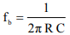  (e) recall and apply the maximum power transfer theorem (f) draw circuits for and recall the properties of emitter and source follower power amplifiers  for source follower)  (g) draw circuits for and recall the properties of push-pull power amplifiers consisting of either emitter or source followers and select and apply the equation  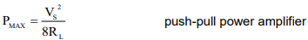  (h) analyse and draw graphs of the waveforms for first order active filters, emitter and source follower power amplifiers and push-pull power amplifiers (i) describe cross over distortion in push-pull amplifiers and its removal using negative feedback.
 | A2 03 Further Microcontrollers (assembly language physical computing)  gce-electronics-book-chapter-3.pdf (wjec.co.uk) | MICROCONTROLLERS  Overview  This topic covers the microcontroller as a programable integrated circuit (PIC) and its  internal structure. It also covers how microcontrollers are interfaced and programed  through flowcharts and assembler language to perform tasks.  Electronic skills  Learners will have the opportunity in this topic to work with microcontrollers,  interfacing them to inputs and outputs and programing them to perform set tasks.  Learners will also use both flowcharts and assembler language to program the  microcontrollers and look at the application of microcontrollers.  Mathematical skills  There are some opportunities for the development of mathematical skills in this topic.  These include: converting between binary and decimal number systems; and drawing  and interpreting flowcharts.  Learners should be able to:  (a) analyse and design flowchart programs to program microcontrollers  (b) recall and describe the structure of a PIC microcontroller as programmable  assemblies of memory, input ports, output ports, CPU, clock and reset  (c) recall and explain the use of interrupts to allow an external device to be  serviced on request  (d) recall and describe the application of a PIC microcontroller  (e) analyse, design and program PIC microcontroller-based circuits using  assembler language. | Weekly homework  Past paper questions as starters  Classwork Marked  Peer and self-assessment  End of unit tests for chapter
 | A2 13 Further Semiconductors (how PN junctions & FETs work)  gce-electronics-book-chapter-13.pdf (wjec.co.uk) | No further information from the exam board available!  The chapter is about how PN junctions and FETs work at the atomic level, with students being able to explain how a PN junction and a FET works with reference to doping, depletion regions, and energy levels.
 | Assembly language coursework (NEA 1) | Task 1 is intended to introduce learners to software control techniques using  assembly language which is widely used to program microcontrollers for consumer  products. It is not expected that learners will be familiar with every instruction in the  instruction set, or use every programming technique available. Several  manufacturers produce PIC development systems which can be used to deliver this  part of the component. The work should not be limited to 'onscreen' design and  emulation, but must involve the actual programing of a PIC chip, and its testing  remotely on a physical circuit. Initial program testing can be carried out using a  development board to prove the program works before final testing on a physical  circuit.  The report must include a listing of the program, a description of how the program  works and testing of the program | Past paper questions as starters  Weekly homework – NEA pages  Peer and self-assessment of NEA progress  End of project assessment (NEA)
Spring 1 | Main project (NEA 2) | Once the learner has decided on a context for the task, they should undertake  appropriate research so that a list of performance parameters (specification) can be  given. It is expected that the design specification will contain realistic numerical  values against which the final performance of the system can be judged.  In each task the overall system should be developed as a number of sub-systems  which should be individually tested and evaluated before being incorporated into the complete system. This will ensure that the complete system develops by a gradual  and incremental process, having been assessed at each stage of its development.  For microcontroller-based projects, a sub-routine can be considered as a sub-system  provided its specification can be tested and evaluated in a similar fashion to a  component-based sub-system. To meet the assessment requirements, a  microcontroller-based project will also need to include, as a minimum, some  component-based processing sub-systems for interfacing signals to and from the  microcontroller (in addition to the microcontroller circuitry).  In each task the system should be fully tested when the project is complete. The  testing should be documented with results being displayed in tables and graphs,  where appropriate. These tests will enable the learner to assess the system and  identify any faults and limitations. The learner should attempt to modify the system to  correct for any limitations and then produce a final set of performance figures for the  completed system. The learner should then evaluate the final system against the  design specification and suggest further developments.  The learner should fully document the development of each task in a report. It is the  evidence contained within this report and the system produced upon which the NEA  should be marked and assessed. The report should contain evidence for each task of  the following sections:  . System planning – including analysis of the problem and a design specification  . System development – including the development of the system in terms of subsystems,  annotated circuit diagrams and description of testing each sub-system  and the recording of results  . System realisation – including annotated block and circuit diagrams; evidence of  layout planning; description of testing of complete systems and the recording of  results and user guide  . Evaluation – including a detailed evaluation of the system against the design  specification and suggestions for improvement.  The report should be presented in a logical order that is clearly presented and easy  to understand. It should contain an acknowledgement of all sources of information  and help. Photographs of the complete physical system must be included in the  report. | Past paper questions as starters  Weekly homework – NEA pages  Peer and self-assessment of NEA progress  End of project assessment (NEA)
Spring 2 | Main project (NEA 2) continued |  | As above
Easter 1 | NEA 1 & 2 hand in
 | Revision
Easter 2 | Revision
 | Exams

