**A Level Law**

# **Exam Technique & Guidance**

# Paper structure

# Top Tips for success

# MCQs advice

# Skills

# How to structure a 5-mark question

# How to structure a 10-mark question

# How to structure a 15 mark question

# How to structure a 30-mark question

# **Paper structure**

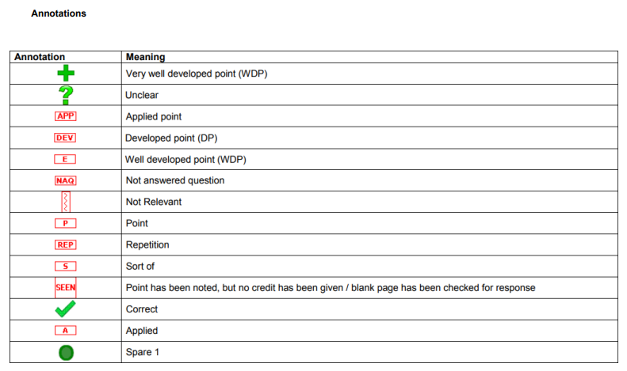

Assessment

|  |  |
| --- | --- |
|  |  |
|  | **Resources for revision:**  · Lesson notes and workbooks  · Law textbooks  · Carousel quizzes available on MS Teams  · Additional textbook handouts, and links to case / law reports websites (these will start to be made available in the MS Teams folder)  · Past papers and examiners reports |

# **Top Tips for success**

Step one- Transform the information from the listed resources and put them into a condensed format (i.e Cornell notes). Consider creating flashcards, mind maps, knowledge organiser, learn the cases and statutes to apply to questions – remember to summarise! Keep it consistent and SIMPLE!

Step two- Active recall- This is a crucial aspect of the revision process and is often missed out. You need to ensure you actively test your memory and ability to recall, you must struggle, you cannot simply rely on the textbook. Therefore, without notes it is worthwhile trying to write what you remember (especially cases) on a mini whiteboard, or even apply the information to an exam question or engage with the carousel quizzes.

Step three- Plan essay questions- Do this as part of the ‘active recall’ it is important you draft plans for essay questions, you can also use this as a checkpoint to check your plan with your teachers and peers. Use the IDEA planning structure within your Cornell notes. The more you use this, the easier you will find it will be to write your answers and you will find that you will write more in the time given. Remember to establish at the start what the offence / liability/Defence / legal issue is – otherwise you are not answering the question.

Step four - Complete (30 mark) essay questions – The two 30-mark questions carry the majority of marks on each paper. Exam technique can only be developed through real life practice. Complete extra essay questions and we will happily provide feedback.

Step five- Engage with feedback- Feedback is pointless without students actively engaging with the advice given, clarify anything you are unsure about with your teacher. This may involve redrafting your essay question in response to feedback.

Other important guidelines:

· 5 hours per subject per week outside of your classroom lessons is the minimum recommended. This can involve revision, research, reading etc.

· Plan your revision, create a revision timetable, and ensure you allocate a reasonable amount of time for yourself. Research shows students often fail to do this and therefore do not stick to the timetable.

· Minimise any distractions, particularly mobile phones/television. Ensure they are on silent or DND. Put them in a drawer or use apps like Forest or Flora.

· Ensure you develop a healthy sleeping routine that fits with the school day (we should not be getting messages on Teams or emails that are being sent at 2am!

· Eat healthily to improve your ability to maintain focus.

· Exercise: run, cycle, walk, gym, swim, stretches, yoga. Ensure you take breaks to ensure a work life balance.

· Practice breathing and meditation – there are loads of great Podcasts, clips on YouTube or Apps you can use.

# **MCQs advice**

* With MCQ type tests, usually **time** is very limited. You have 1.2 minutes for each MCQ, so divide the time on all MCQs properly. This does not mean divide time equally. For example, Maths MCQs may take more time to solve while English MCQs should take lot less than the time allocated.
* **Read** the MCQ and before reading the choices, think in your mind for correct answer and then read the choices. It will help you to choose the correct choice or the answer.
* There will be some choices that would surely know are wrong, skip these wrong choices first and focus on the rest choices for correct answer. It increases your chances to select the correct choice.
* For answering MCQs you are directed to record your answers in a specific way. Ensure you follow the directions or your work with become void.
* Practice sample MCQs tests in timed environment. These let you know how you perform under time pressure.

***Question: Which of the following statements is true?***

* Select the correct response and ensure the circle is completely filled in alongside the appropriate answer
* If you change your mind, cross out the original answer and completely fill in the circle next to the answer you now wish to choose
* If you do change your mind, refer back to the instructions at the start of Section A to ensure you are following them precisely; the key is to make sure your answer is clear

**How to answer a short answer question**

Exam style question (1)



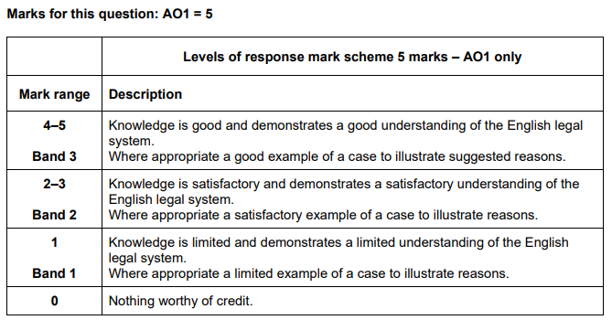

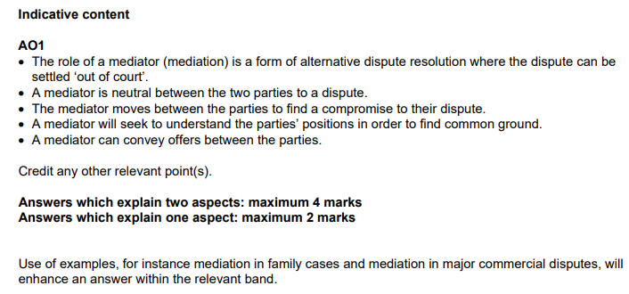

Although there is no scenario in this question, students must still follow the IDEAL structure to give clarity.

Students must:

* Identify the subject of the question in this case ‘mediator’
* Define the subject of the question – what is a mediator?
* Explain the focus of the question – in this case “3 aspects”
* Apply the 3 aspects clearly in relation to the mediator.
* Link back to the question in the conclusion

Exam style question (2):

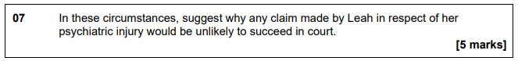

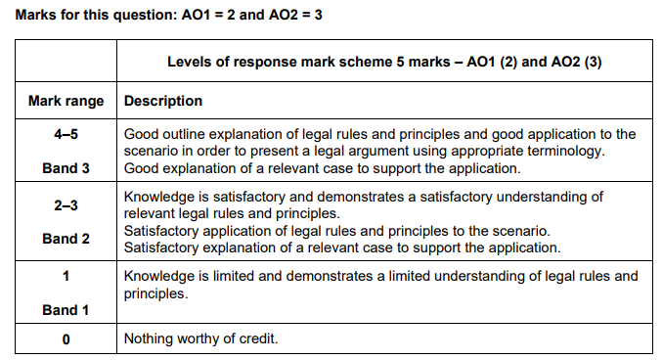

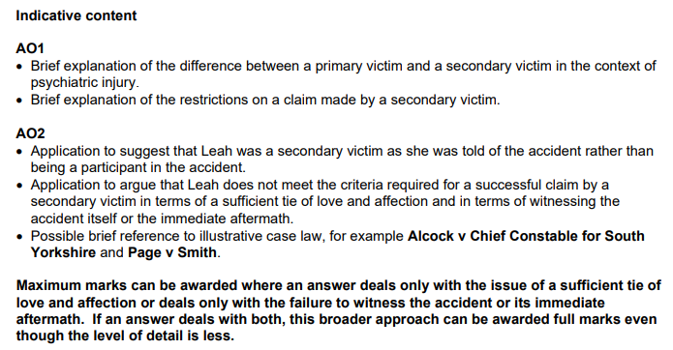

**Model answer**

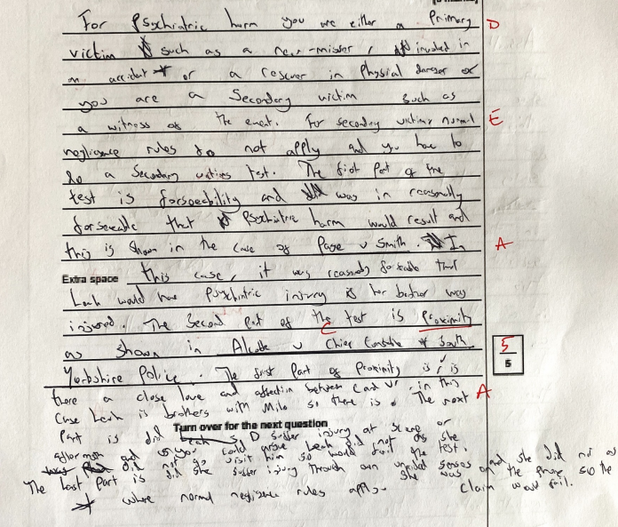

# **How to structure a 10-mark question**

|  |  |
| --- | --- |
| **Identify** the relevant legal concept/Offence/defence in the question   * Clearly state what the relevant law is in your first sentence * Be clear and concise (max. 1 or 2 sentences) | **Content** |
| D may be liable for Murder. |
| **Define** the relevant concept/Offence/defence in the question   * Clearly state how this area of law has been defined either in statute or in a case, perhaps by a judge (e.g murder was defined by Lord Coke in a 17th century case) * Do not provide your own definition – this is Law, not your opinion. Your job is to accurately state what the law is. | Murder is defined by Lord Coke as ...  “unlawful killing of a reasonable person in being under the Queen’s peace, with malice aforethought, express or implied” |
| **Explain** the elements of the legal concept/offence/defence/   * Identify the specific elements that make up the offence/defence and * Explain of the elements (e.g Unlawful is an element of murder i.e this must be proven. What constitutes unlawfulness in the eyes of the law? * Support each element with relevant statute and/or cases (not every element will have a corresponding case but if one exists, you will be expected to use this to illustrate the relevant element. Is there a case that illustrates when a killing was considered to be unlawful? | To be guilty of murder, the prosecution must prove beyond reasonable doubt that there has been the following:   * A killing of a person in being * Killing was unlawful * Killing occured during the King’s peace * Killing occured with malice aforethought that was either express or implied. * You must also explain causation and transferred malice if relevant |
| **Apply** the law to the scenario   * Apply each of the element you have explained to the given scenario – ask yourself how the defendant/claimant/prosecution have met each of the element * Reach a reasonable conclusion as to whether the defendant is liable, or the prosecution has met each element for **and** what the remedy or penalty might be | In this scenario...   * ...there was a killing because ... * The actions of the Defendant led to the victims death (causation) because... * Killing was unlawful because... * Killing occurred during the King’s peace because... * Killing occurred with malice aforethought that was either express because ... (or implied because...) |

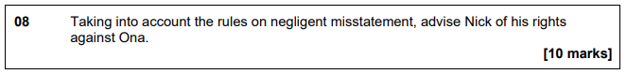

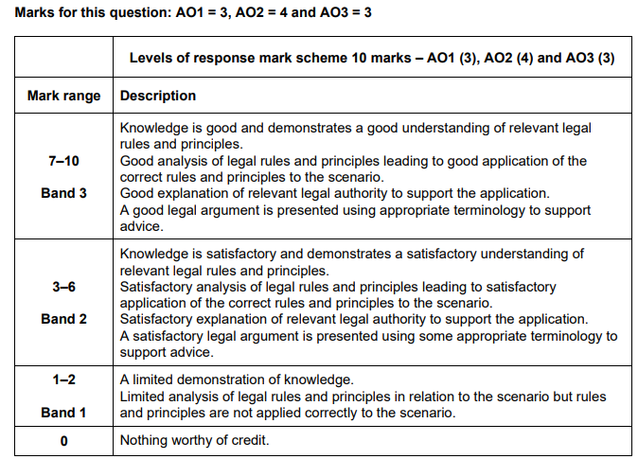

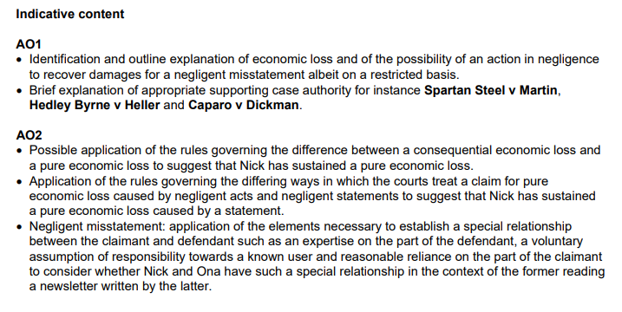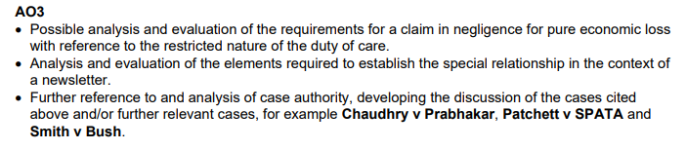

# **How to structure a 15-mark question**

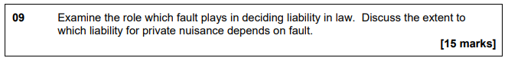

|  |  |
| --- | --- |
| **Identify** the relevant legal concept/Offence/defence in the question   * Clearly state what the relevant law is in your first sentence * Be clear and concise (max. 1 or 2 sentences) | **Content** |
| *One way in which the courts determines liability in law is through the apportioning of fault* |
| **Define** the relevant concept/Offence/defence in the question   * Clearly state how this area of law has been defined either in statute or in a case, perhaps by a judge * Do not provide your own definition – this is Law, not your opinion. Your job is to accurately state what the law is. | *Fault is...*  *It is used to determine liability in terms of ... of intention (purpose), recklessness (foresight of risk), negligence (failure to reach the standard of the reasonable person) and strict liability (imposition of liability even in the absence of fault)* |
| **Explain** the focus of the question – this may be a legal concept/offence/defence/   * Identify the specific elements that make up the offence/defence and * Give basic explanation of the elements * Support each element with relevant statute and/or cases (not every element will have a corresponding case but if one exists, you will be expected to use this to illustrate the relevant element. | *To be liable for an action for private nuisance, it must be proved on the balance of probabilities that there was unlawful indirect interference with a person’s use or enjoyment of their land resulting in loss of amenity and/or physical damage and the notion of reasonable use based on factors such as locality, duration, intensity, malice and sensitivity of the claimant.* |
| **Apply** the law to the concept/Offence/defence in the question in this case private nuisance in order to **Evaluate** its importance   * Apply each of the element you have explained to the given scenario – ask yourself how the defendant/claimant/prosecution have met each of the element * Reach a reasonable conclusion that answers the question in this case as to extent that fault plays a role in deciding liability in law. | *Fault can be seen in the court process, for instance its contribution to the assessment of the severity of any criminal punishment or the extent of any civil remedy and its function in allocating responsibility between the parties in terms of defences...*  *In the context of nuisance fault can be seen in* absence of *any requirement for negligence and the standard of the reasonable person in assessing the defendant’s actions (the assessment being based on “give and take” between neighbours and the idea of unlawful interference)...*  *It can also be seen in the application to the defendant for not having regard for neighbours...*  *It can also be seen in the defences available to a claim in private nuisance and to remoteness of damage. (Miller v Jackson and Sturges v Bridgeman)...*  *In* ***conclusion****, on the one hand, liability in private nuisance is not based on fault, as the defendant is principally judged by the standard of unlawful interference, but on the other hand, there are elements of fault such as the malice factor* |

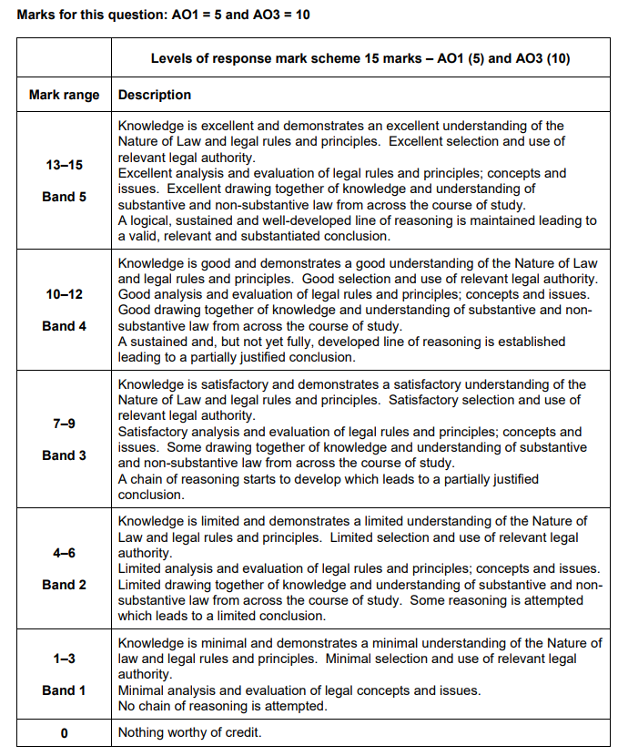

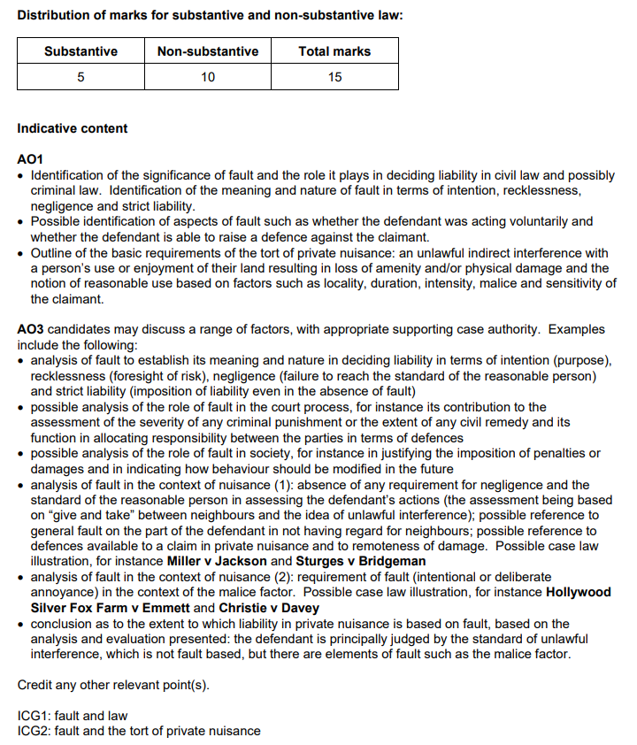

# **How to structure a 30-mark question**

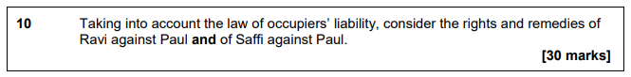

|  |  |
| --- | --- |
| **Identify** the relevant legal concept/Offence/defence in the question   * Clearly state what the relevant law is in your first sentence * Be clear and concise (max. 1 or 2 sentences) | **Content** |
| *The relevant applicable law in this case is the Occupier’s liability Act of 1957 and /1984* |
| **Define** the relevant concept/Offence/defence in the question   * Clearly state how this area of law has been defined either in statute or in a case, perhaps by a judge * Do not provide your own definition – this is Law, not your opinion. Your job is to accurately state what the law is. | * *The OLA 1957 governs the liability that is owed by owners to lawful visitors...* * *The OLA 1084 governs the liability that is owed by owners to tresspassers...* |
| **Explain** the legal concept/offence/defence/   * Identify the specific elements that make up the offence/defence and * Give detailed explanation of the elements * Support each element with relevant statute and/or cases (not every element will have a corresponding case but if one exists, you will be expected to use this to illustrate the relevant element. | * *To apportion liability under the OLA 1957, there must be:*   + *premises, defined under section... as ....*   + *There must be an* ***‘occupier’*** *defined under section.... as ....*   + *There must be a lawful visitor. Section...defines a lawful visitor as...* * Possible **defences** might be...   + This is defined as...   + To be able to rely on this defence the respondent must show the following...   --------------------------------------------------------------------   * *To apportion liability under the* ***OLA 1984,*** *there must be:*   + *premises, defined under section... as ....*   + *There must be an* ***‘occupier’*** *defined under section.... as ....*   + *There must be an unlawful visitor. Section...defines a unlawful visitor as...* * Possible **defences** might be...   + This is defined as...   + To be able to rely on this defence the respondent must show the following... |
| * **Apply** the law to the concept/Offence/defence in the question in this case private nuisance   + Apply each of the element you have explained to the given scenario – ask yourself how the defendant/claimant/prosecution have met each of the element for the offence/defence * Reach a reasonable conclusion that answers the question for each party. | *In relation to* ***Paul****...*  *The premises is... because...*  *The occupier is ... because...*  *The lawful/unlawful visitor is... because...*  *However Paul may be able to rely on the defence of ...*  *This is because ...*  *-*  *-*  *-*  *-*  *In relation to* ***Safi****...*  *The premises is... because...*  *The occupier is ... because...*  *The lawful/unlawful visitor is... because...*  *However Safi may be able to rely on the defence of ...*  *This is because ....:*  *-*  *-*  *-*  *-* |

