# 

# **A Level Economics**

# **Exam Technique & Guidance**

# Paper structure

# Top Tips for success

# MCQs advice

# Quantitative Skills

# How to structure a 9-mark question

# How to structure a 15-mark question

# How to structure a 25-mark question

# **Paper structure**

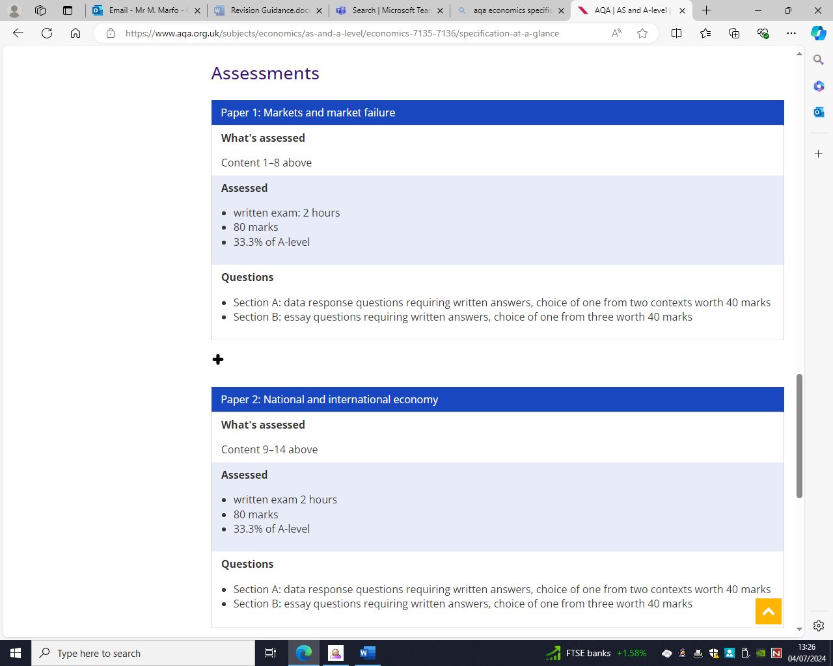

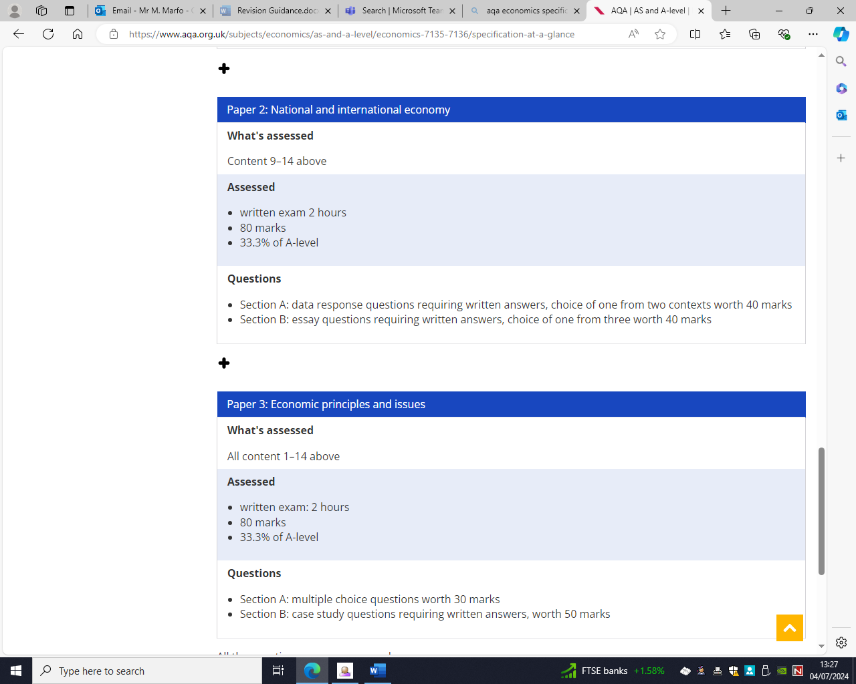

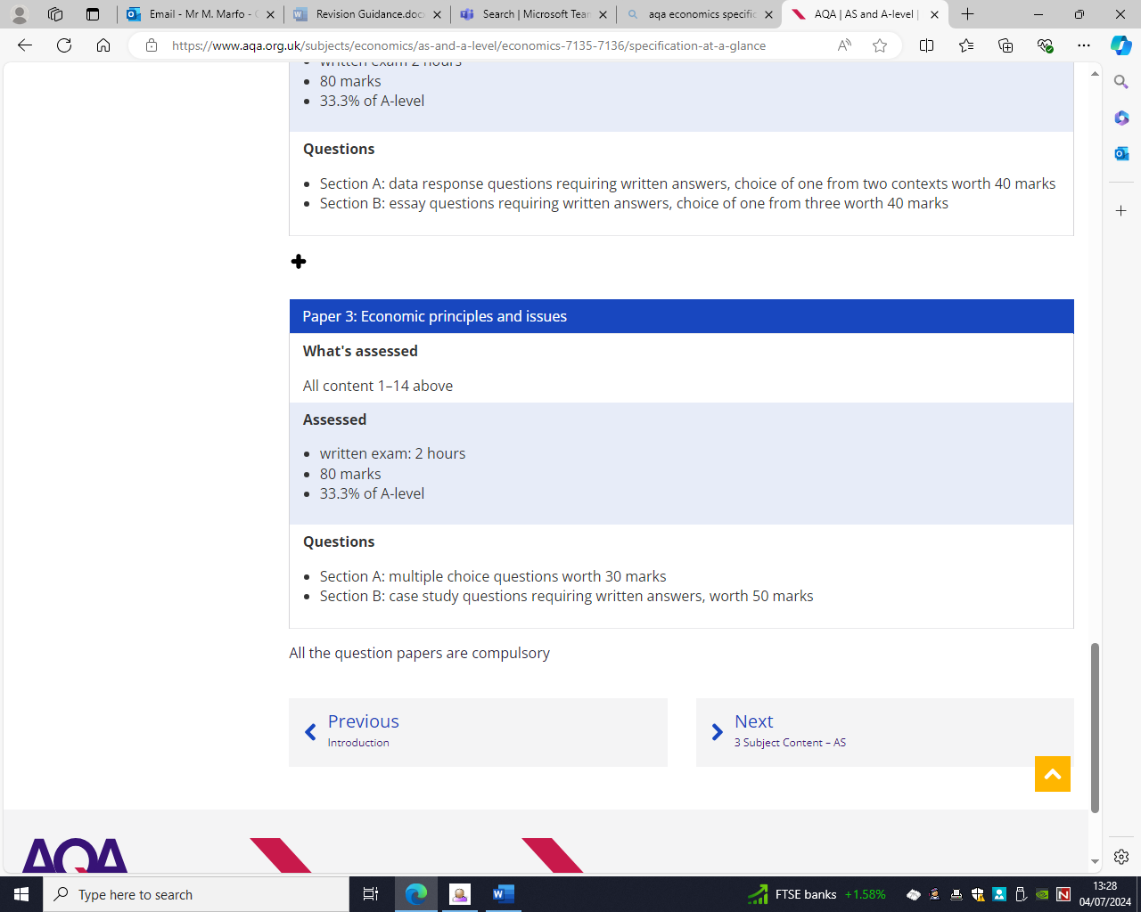

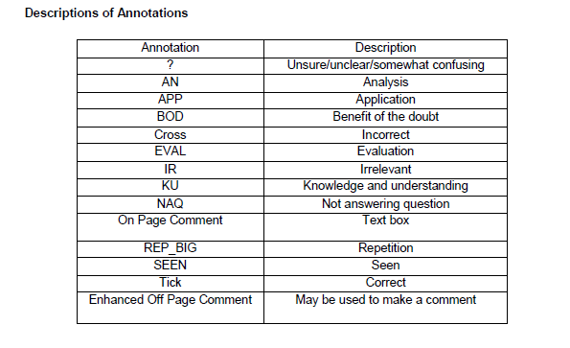

# **Top Tips for success**

1. **Time management.** You must stick to the rule of a 1.2 per mark. Spending too long on the on questions results in less time to do others which often results in students failing to read questions and/or not finishing the paper.
2. **Read each question carefully and ensure you answer the question you are asked**. Often using the key words in the question at the start of each paragraph can help ensure your answer is focused throughout
3. **Make sure that you apply the case study and your economic knowledge.**

Good application can be achieved by being completely in context, manipulating data as well as combining data. Being in context means that your answer relates to the business in the case study as well as the problems or issues that the business is specifically facing.

1. **Analysis.** To achieve GOOD analysis, you must provide a **coherent and logical multi-stage argument** that is focused on the question.
2. When it comes to analysis, think **HOW and WHY.** For example, if you say that increased labour productivity will reduce labour costs per unit, **explain HOW and WHY** this is important to the business you are writing about. Put your answer in CONTEXT.
3. Evaluation. To achieve GOOD evaluation, you must provide a **clear and well supported judgment** in relation to the question being asked which is **built on prior analysis and evidence**. A useful strategy is to explain what the most significant point or argument was that led you to that judgement. Why did you choose one argument over another? Why did you reject one?
4. Efficient use of the **case study** is crucial. Underlining everything often results in key points being missed. Highlight the key points you want to use to put your answer in context.
5. Definitions. If there are two key words in the question **you only need to define ONE.** Defining both wastes time. Definitions only contribute to your knowledge marks. Define one key term well and then move on.
6. **Calculations.** Work quickly and accurately and keep to the time limit. If (for a 6-mark question) after 6 minutes you are still struggling then move on. It is unlikely that further time will result in a significant increase in your mark for that question and you run the risk of rushing the last question. ALWAY, repeat, ALWAYS show your workings when doing calculations.
7. **Read the examiners reports and mark schemes** for past papers. They are free and are designed to help you improve

# **MCQs advice**

* With MCQ type tests, usually **time** is very limited. You have 1.2 minutes for each MCQ, so divide the time on all MCQs properly. This does not mean divide time equally. For example, Maths MCQs may take more time to solve while English MCQs should take lot less than the time allocated.
* **Read** the MCQ and before reading the choices, think in your mind for correct answer and then read the choices. It will help you to choose the correct choice or the answer.
* There will be some choices that would surely know are wrong, skip these wrong choices first and focus on the rest choices for correct answer. It increases your chances to select the correct choice.
* For answering MCQs you are directed to record your answers in a specific way. Ensure you follow the directions or your work with become void.
* Practice sample MCQs tests in timed environment. These let you know how you perform under time pressure.
* Watch out all students taking AQA A Level Business in June 2018. A new MCQ question format has appeared on Paper 1 which looks like it might become an examiner favourite.

***Question: Which of the following statements is true?***

* Select the correct response and ensure the circle is completely filled in alongside the appropriate answer.
* If you change your mind, cross out the original answer and completely fill in the circle next to the answer you now wish to choose.
* If you do change your mind, refer to the instructions at the start of Section A to ensure you are following them precisely; the key is to make sure your answer is clear.

# **Quantitative Skills**

**Example 1**

# 

**Example 2**

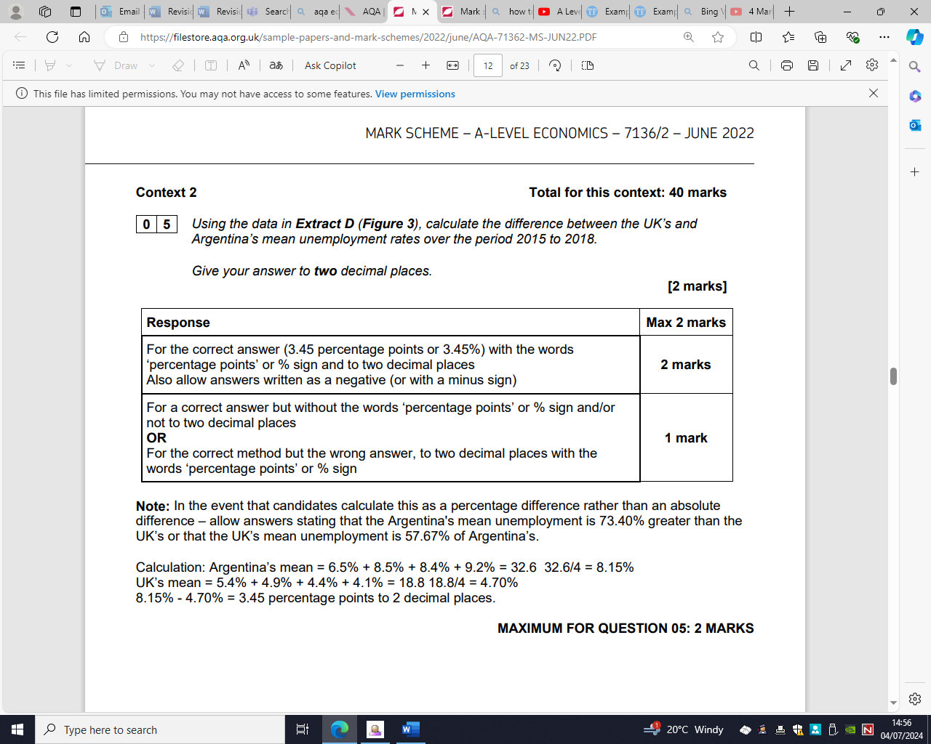

# **How to structure a 9-mark question**

Recommend the following answer structure:

* Definition of one or two key terms, usually those in the question.
* Two basic points.
* Evidence from extract.
* Draw diagram.
* Explain / chain of analysis, including referring to the diagram.

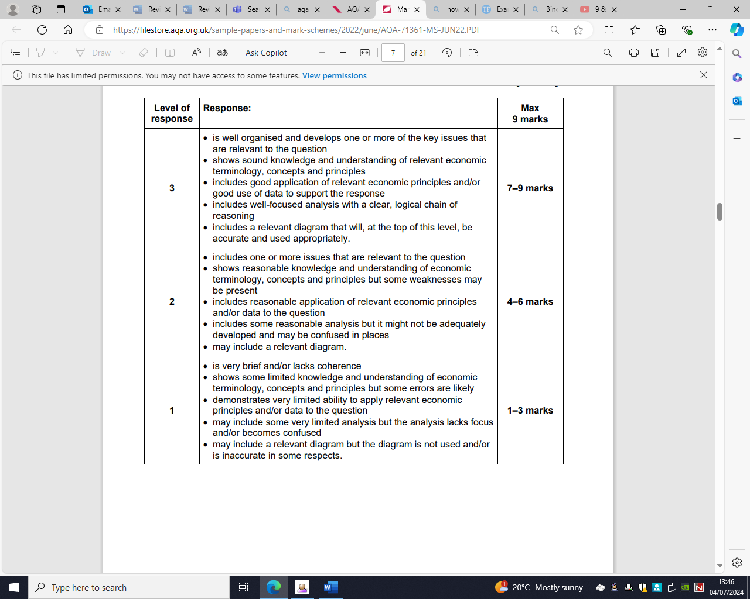

**9m-L3**

* A good response that focuses on many of the demands of the question
* Demonstrates a depth and range of knowledge and understanding of issues in the question
* Include a well drawn and annotated diagram.
* Demonstrates analysis which is well developed
* Applied effectively to the context

## **Example question**

Using extract B, explain why pollution may represent a market failure”

Market failure is when the market does not allocate resources efficiently. Pollution can cause a negative externality in production. A negative externality is a harm to a third party not directly involved in the transaction.

Pollution from the production process of a car plant could spill into nearby rivers. This could harm the fish supply in the rivers, reducing the income for fishermen. Pollution from industry for example may lead to “global temperatures rising more than 1.5 degrees celsius above pre-industrial levels” according to extract B. This could lead to rising sea levels which could lead to flooding and the displacement of production.

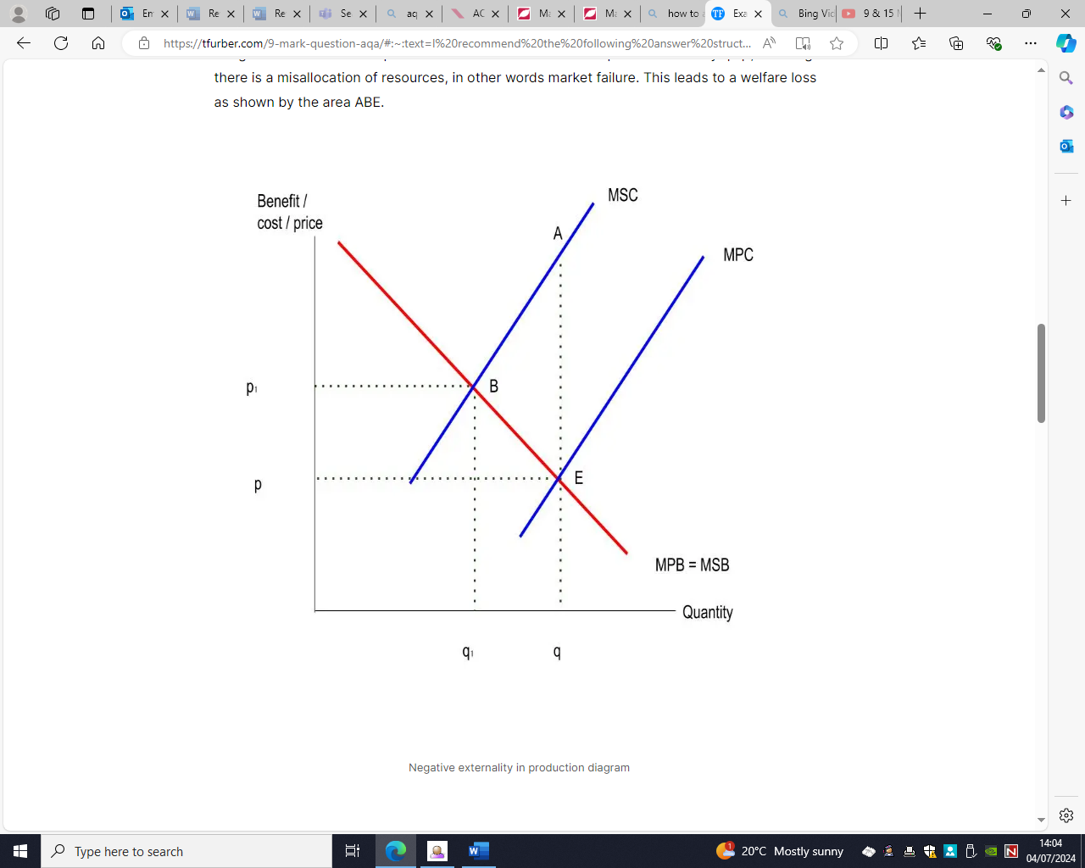

The diagram shows a negative externality in production. Consider the market for cars. A negative externality in production means the marginal social cost of car production exceeds the marginal private cost. The free market produces where marginal private cost = marginal private benefit at q. But the socially optimal quantity occurs where marginal social cost = marginal social benefit at q1. This means the free market overproduces cars by q-q1, meaning there is a misallocation of resources, in other words market failure. This leads to a welfare loss as shown by the area ABE.

# **How to structure a 15-mark question**

Recommend the following answer structure:

* Definition of one or two key terms, usually those in the question.
* Three/two basic points.
* Evidence from extract.
* Draw diagram(s).
* Explain / chain of analysis, including referring to the diagram.
* Refer to the question and use examples from the extract data or real-world examples.

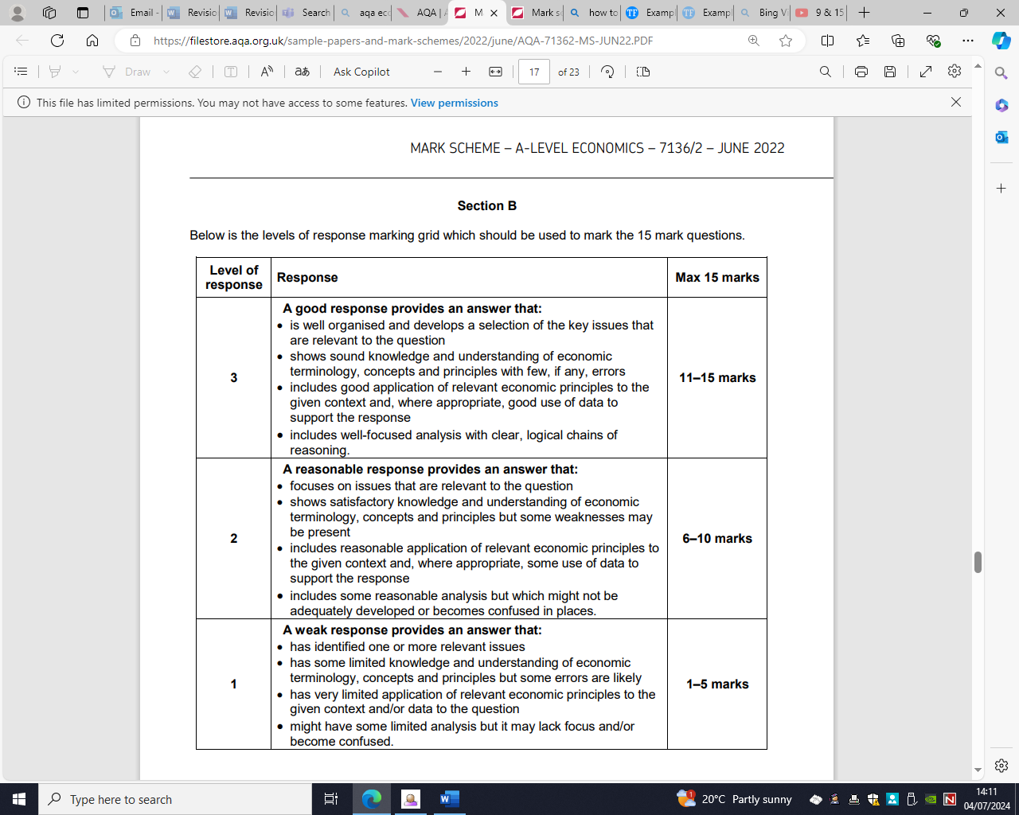

# **How to structure a 25-mark question**

Recommend the following answer structure:

* Introduction
* Analysis (including relevant diagram and application)
* Evaluation
* Analysis (including relevant diagram and application) if applicable.
* Evaluation
* Depending on depth of your previous points, add another round of analysis and evaluation.
* Conclusion.

**A conclusion has these key elements:**

1. Answer the question.
2. Justify your answer in step 1.
3. Consider other evaluation points, including real-world context, for further justification or that may go against your answer.

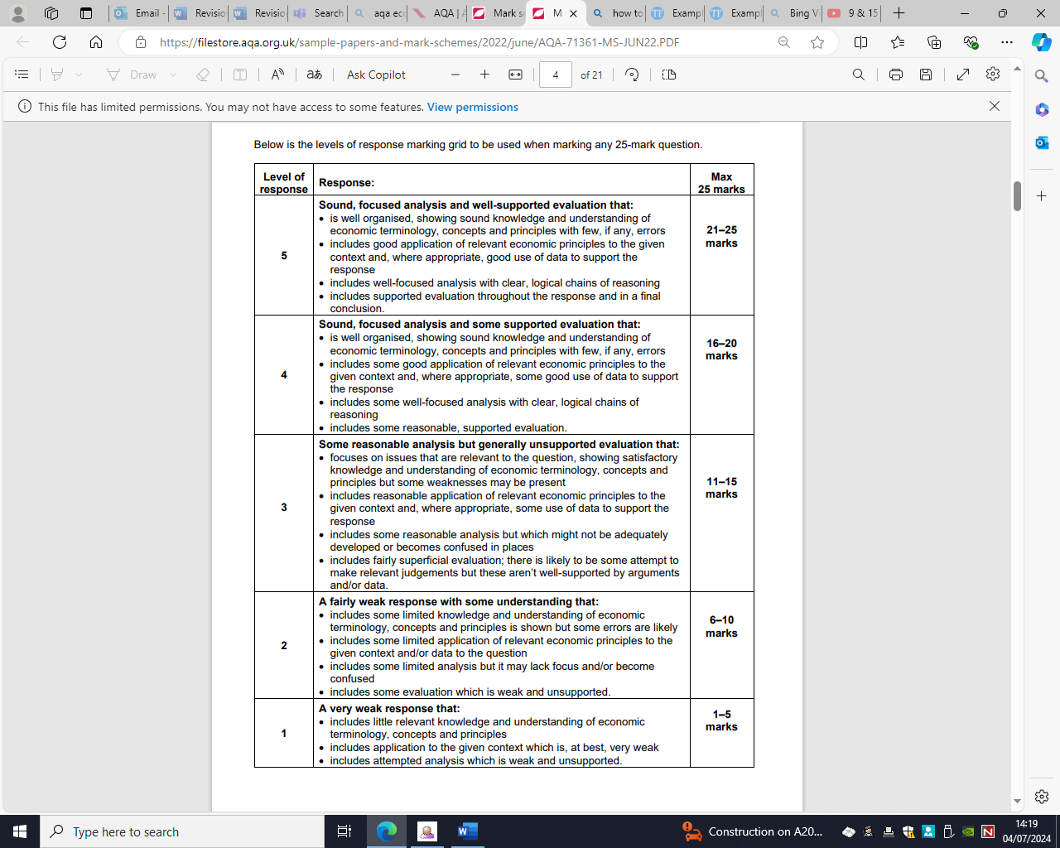

**25m- [L5]**

* An excellent response overall that is fully focused on the key demands of the question
* Demonstrates a depth and range of knowledge and understanding that is precise and well selected Demonstrates analysis throughout which is well developed
* Applied effectively to the context and considers a balanced range of the issues in the question
* Makes judgements or provides solutions which are built effectively on analysis
* Shows balance and has a clear focus on the question as whole throughout

**Evaluation**

|  |  |
| --- | --- |
| ***Decision***  To begin your evaluation, you should simply decide on which side of the argument you agree with. |  |
| ***It depends on***  The success of every decision will depend on a number of factors, aspects which the firm should consider prior to finalising their decision. You should include these factors here. Think about financial and operational factors which firms consider often. These “depends on” factors should be explained in this sector. Aim to include at least three. |  |
| ***Short- and long-term factors to consider***  Any decisions will result in both short- and long-term consequences. When deciding on your short-term factor think about the immediate impact the decision will have on the stakeholders. In this context it may be worth thinking about the impact over a 12month period. Long term consequences will have a wider impact for the future. |  |
| ***Cost (opportunity)***  Having made your decision what is the option forgone? What will the firm not be able to do having made their choice? What opportunities have they sacrificed by making this choice? |  |
| ***Other factors which might impact the decision***  This section is an opportunity for you to incorporate any other factors into your answer. For example, you may want to introduce internal and external factors which you have not already discuss. In addition, it is advisable to include points related to functional areas which have not already been include (HR,Ops,Finance,Marketing) |  |
| ***Main point***  End your paragraph with a clear, concise sentence with reaffirm your main points and links directly to the hook in the question. |  |

***How to answer a 4 marker questions***

[*4 Marker - Paper 1 & 2 - AQA A Level Economics - YouTube*](https://www.youtube.com/watch?v=GQfQr2WGuqA)

***How to answer 9 & 15 maker questions***

[*9 & 15 Marker - Paper 1, 2 & 3 - AQA A Level Economics (youtube.com)*](https://www.youtube.com/watch?v=_lZhD3yB_Ss)

***How to get top grades in A-level Economics***

[*How to Get a Top Grade in A Level Economics - 12 Top Teacher Tips for Success | Reference Library | Economics | tutor2u*](https://www.tutor2u.net/economics/reference/how-to-get-a-top-grade-in-your-a-level-economics)

***How to answer 15 marker with an example***

[*Example 15 mark answer in style of AQA Economics (tfurber.com)*](https://tfurber.com/15-mark-question-aqa/)

***How to answer 25 marker with an example***

[*Example 25-Mark Essay in style of AQA Economics A-level (tfurber.com)*](https://tfurber.com/example-25-mark-essay-in-style-of-aqa-economics-a-level/)

***How to structure a 25 marker***

[A Level Economics: 25 Markers - How to Structure Your Answer (youtube.com)](https://www.youtube.com/watch?v=1LJcle31mdk)